IMPROVING DAM DATASETS TO IDENTIFY MICRO-HYDRO SUITIBILITY: A SPATIAL DATA DRIVEN APPROACH

Perry Godse¹, Michael Wray², Dr. Charlotte Macalister³, Dr. Kevin Hamdan⁴

¹PhD Student, Department of Civil Engineering, Carleton University, Canada
²Department of Geography & Environmental Studies, Carleton University, Canada
³Institute of Water, Environment and Health, United Nations University, Canada
⁴Associate Professor, Physical Geography and Geomatics, Carleton University, Canada

ABSTRACT
Hydraulic systems have been relied on for over 2000 years, and as technology continues to evolve, the demand for power has increased competition for shared water resources. The widespread hydroelectric infrastructure boom of the late 20th century has led to significant environmental impacts, raising the question of what constitutes the artificial hydro footprint. To establish a comprehensive global dataset of dam infrastructure, existing dam inventories are geo-referenced and integrated with spatial datasets to refine the number of dams per basin region. Leveraging established dam and reservoir inventories—including the World Register of Dams (WRD), GRanD national inventories, GOODD, and ICOLD — GeoDAR v1.1 was developed as the first effort to harmonize global dam datasets. In its preliminary form, GeoDAR v1.1 consolidates 23,680 dam points, 20,214 reservoirs, and a total reservoir catchment area of 492,068 km².
Given that the dataset is built from multiple local geo-referenced sources, harmonization with new regional datasets is essential for continual improvement and validation. This study presents a harmonization methodology for refining GeoDAR v1.1 using an inverse geospatial analysis approach. The methodology is validated by integrating new regional datasets to the Mekong Basin and the Outaouais Basin. Through this process, inverted clustering within the harmonized dataset is employed to assess hydro-river availability using HydroSHEDS data.
This harmonized dataset and analysis framework is further extended to hydropower industry applications. Specifically, new sustainable practices for identifying micro-hydro site suitability are examined using the same geospatial principles. These assessments incorporate exclusionary factors, such as protected areas and existing hydropower infrastructure, to refine site selection. Rather than relying on heavily weighted criteria to pinpoint specific locations, this study employs inverse spatial analysis to evaluate the relationship between dam clusters and river basin hydraulic availability. The method provides valuable data for pre-feasibility studies and map visualizations to support hydropower planning and development.

Introduction

Dams have nearly 100 years of service life. As many large hydropower developments were built in the 20th century, a safe-to-fail approach in maintaining the hydro network can be employed to maintain water and power needs (Kim et al., 2019). As infrastructure fails, stakeholders may encounter an “infrastructure trolley problem” with unequal impacts on people, contractors, water supply, and revenues (Kim et al., 2019). The Hydropower generation and the water supply components can be sustainably developed and rehabilitated by carefully planning sustainable micro-hydro developments to meet current and future needs, in turn affecting all stakeholders on a minimal more equitable scale. This also leads to developing more small, resilient infrastructure that have minimal environmental footprints while tailoring the power needs to applications as required. The potential of spread-out power developments and ownership further broaden the water supply and usage of our hydro rivers and provides more interdisciplinary opportunities to examine and collect geographic & engineering data. Such data is useful for monitoring the state of the hydrosphere, which can be analyzed using Geographic Information Systems (GIS).

ArcGIS Pro facilitates visual presentation and geo-processing of dam datasets in specific regions. This can aid in applying the concept of geoengineering (large-scale climate intervention of Earth’s natural systems) to improve the current understanding of regional hydrography.

The prevalence of diverse hydropower assets across global basins responds to the power and water supply demands for regions in need for water and electricity. This abundance of dam projects is at the expense of fragmenting rivers, flooding regions, and in turn, displacing communities (Jumani et al., 2020). As a result of over-damming, the climate geography of a region changes over time, and communities relying on aging infrastructure then face socio-economic and infrastructure risks (Wada et al., 2016). Due to information availability, collection, and privacy; available data can be altered and/or encoded to provide minimal information. In response to the need to improve global water security, global spatial inventories are being developed to define human impacts on the hydrosphere and undisturbed environment.

Currently, there is a lack of publicly available clean and usable spatial inventories and datasets of global hydro projects. One of the most comprehensive datasets is the world dam register (WRD) that is regularly updated by the International Commission that on Large Dams (ICOLD). ICOLD WRD accounts for 60,000 large dams in the world with a hydraulic head of 5 to 15 meters and 3 million m³ of water storage capacity, notably from nations willing to provide data (Wang et Al. 2022). ICOLD WRD provides 40 attributes but lacks georeferencing, leading to multiple registers needing to be referenced. Other datasets such as the Global Reservoir and Dam Database (GRanD) (Lehner et al., 2011), GlObal georeferenced Database of Dams (GOODD V1) (Mulligan et al., 2020), Global River Width from Landsat (GRWL), Global River Obstruction Database (GROD) and AQUASTAT are harmonized to produce GeoDARv1.0 and now, GeoDAR v1.1 (Wang et al., 2022).

GeoDAR v1.1 contains 17 primary column key identifiers documenting flow properties and with some identifiers containing encoded data which can only be referenced with permission from sources such as ICOLD, who offer data through a paid subscription. For this reason, geocoding source, quality assurance, and encoding are all documented within GeoDAR v1.0 and v1.1. The main challenges within the database revolve around geocoding or reverse geocoding in the event of missing information on hydro developments in different regions. Considering data collection is not standardized globally, subtle differences in key heuristics such as name versus project name, prevents geocoding, as collected data may conform to location specific and project-based conventions. As regional governance varies across the world, data cannot always be reliable or referenced. Hence, the need for a variety of referable independent datasets with a variety of useful key attributes. This also presents the challenge of cleaning and joining spatial dam inventory and reservoir data to continue the ongoing process of harmonizing and normalizing global dam datasets.

1.1 Purpose
GeoDARv1.1 represents a global effort to produce the most up to date the global dam dataset from referencing large inventories and in this study, independent regional inventories to facilitate the ongoing improvement of the data. Using a semi-automated deduplication by proximity, GeoDAR v1.1 for each the Mekong Basin passing through Vietnam, China and Laos, Thailand and Myanmar, and the Outaouais Basin along the Ottawa River in Canada, are merged with regional ADPC and Ontario Dam Inventory datasets respectively to provide an updated hydro project count. The updated Outaouais Basin regional dam inventory is then applied to perform a Micro Hydro suitability study using inverse spatial selections of key attributes. The resulting dataset is conceived to provide an as-built footprint of the current infrastructure, whose intent is to locate potential future sustainable hydro projects than is currently present (Ontario Energy Board, 2021).

1.2 Background
Defining a micro-hydro footprint involves defining the built infrastructure. The gross geographical reach of new potential suitable micro-hydro site locations is spatially related to existing, built dam infrastructure and available rivers using specific deciding requirements within a matrix (Jozaghi, 2018). In this study, the approach involves an as-built dam cluster analysis to determine undisturbed available regions without any hydropower development. As a result, the inverse clustering identifies potential regions to begin safe-to-fail hydro developments in preparation for dam infrastructure decommissioning for existing infrastructure.

A conventional mode of hydropower is to create basins through a variety of technologies, such as; run of the river stations, pumped or reservoir storage, pumped storage, hydrokinetic, and underground hydro (Future Energy, 2014). This has been implemented on incremental scales such as a micro;5kW -100 kW, mini; 100 kW - 1 MW, small; 1 MW - 10 MW, medium; 10MW – 100MW, and large-scale projects greater than 100MW (Carrasco, 2021). However, large-scale projects, as demonstrated in the Mekong region in Asia, contain many dam failures due to over-damming and fragmenting rivers. This destroys the geographic landscapes and displaces communities (Jumani et al., 2020).

To define sustainable hydro projects using inverse geospatial relationships, the main pitfalls of both large- and small-scale hydropower projects can be summarized by comparing the positive and negative impacts of each type of development.

Large-scale hydropower projects provide flood protection, drinking water, and irrigation water, but lack environmental sustainability as these cause inundation, restricted water access, population resettlements, degrade the reservoir basin via siltation, and cause declines in biodiversity.
Small-scale hydropower projects: however, have been found to produce unequal social impacts due to water budget allocation on fragmented tributaries as illustrated in the case of the Red River Basin in China. These projects have caused unequal social impacts due to river fragmentation, watershed management, and irrigation. This puts communities that are highly dependent on the small hydropower projects (SHP) at risk.

SHP can also fall within two categories; run-of-the-river (RoR) hydropower and small dam projects. This broadens the applicability of geospatial data in deciding micro-hydro feasibility by grouping small dams and sustainable hydropower projects instead of excluding all dam projects. In the case of the heavily fragmented regions in China, this may present problems due to the micromanagement of water inventory distribution. Communities that are located between significant dams, reservoirs, and irrigation channels, either upstream or downstream, are adversely affected in the event of failure. Conversely, in the case of micro hydro or run-of-the-river plants, pitfalls such as river diversion, irrigation floods, droughts, and inundations can adversely affect communities which rely on this power (Harlan et al., 2021). Comparatively, in the Outaouais basin region along the Ottawa River in Canada, the suggested pitfalls as a result from fragmenting are not present due to a current low number of projects and minimal large-scale ecological disturbances attributed to fragmented rivers (Thieme et al., 2021).

Along The Ottawa River, 38 MW of power is generated from six power generating stations (Atlas, 2021). In examining the power constraints, failures in the region account for 10%-25% of transmission failures. The latter is due to environmental and equipment failure. However, the bulk of the failure mitigation is through hyper-responsive crews, which is not sustainable as the bulk of the hydropower is produced at six aging facilities (Atlas, 2021). Considering mitigation, broadening the range of hydro projects through feasible Micro Hydropower MHP provides a robust multisource of pre-feasible hydro-ready locations. Due to the availability of undisturbed rivers in the Outaouais region, a data driven approach can be used to determine the feasibility of hydropower developments as opposed to determining singular ad-hoc high-power sites.

Unlike Mekong, there is still the opportunity to integrate sustainability in hydropower in Canada as opposed to installing MHP in exploited regions, as demonstrated in the Mekong region through their environmental disasters. There is also less social and community pressure in the available areas as Canada is still a growing and developing country (Harlan et al., 2021). By coupling SHP & RoR developments, it can be possible to redefine the potential of the Outaouais River Basin through inverse geoprocessing relationships as opposed to performing multivariable analyses. This provides a visual suitable site footprint for MHPs that conform to minimum hydraulic head and water flow requirements to facilitate the integration of safe-to-fail projects and sustainably in new hydropower infrastructure (Cook, 2012).

Objectives

In evaluating MHP feasibility, obtaining geospatial data of current sites and their respective hydrology is required. Harmonizing and relating dam datasets to environmental and hydrologic data is crucial to define the current built infrastructure of a given region. In conjunction with UNU-INWEH and project Servir-Mekong, the primary objective of this study is to use independent regional dam datasets to improve and harmonize GeoDAR v1.1 (Macalister, 2022). As the analysis is repeatable in any river basin river basin, the secondary objective is to use the updated dataset is to determine suitable MHP locations in the Outaouais River Basin using an inverse relationship between dam locations and suitable streams. By applying and automating the methodology within the Mekong Basin to the Ottawa River Basin, the available potential inventory of unused rivers and suitable hydro locations can be determined using hydromechanical criteria coded within both GeoDAR v1.1 and the local dataset's keys.

Methodology

3.1 Geo-Referencing Global Dam Registers
To develop a methodology from GeoDAR v1.1, the understanding of the derivation of GeoDAR v1.0 is crucial for determining the convention of harmonizing additional datasets. GeoDAR V1.0 was harmonized by using paid ICOLD data, then referenced as illustrated in the flow diagram in Figure 1, using geo-referenced WRD dams, ICOLD WRD, the google API for geocoding, then supplemented by Servir-Mekong data (Wada et al., 2017). Subsequently, GRanD V1.3, UCLA Circa 2015 Lake Inventory and HydroLAKES v1.0 from HydroSHEDS provided a harmonization of the dataset to refine the total dam count to 23,680 dams in GeoDAR v1.1 from 21,051 dams in GeoDAR v1.0. Concurrently, the reservoir count was attributed to account for 20,214 reservoirs in association with the dam data (Wang et al., 2022). Using a variety of quality assurance geocoding techniques, the data set was iteratively improved based on the heuristics of dam and reservoir name and provided key attributes. GeoDAR v1.1’s methodology is demonstrated in Figure 1 and Figure 2 (Wang et al., 2022).
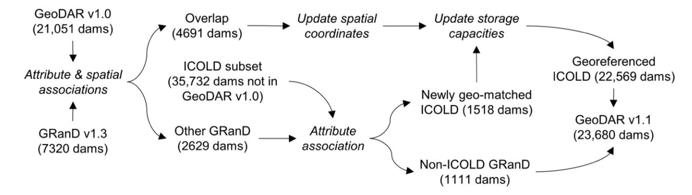
Figure 1: GeoDAR V1.1 Geospatial Model figure 6. Adopted from Wang et al., 2022.
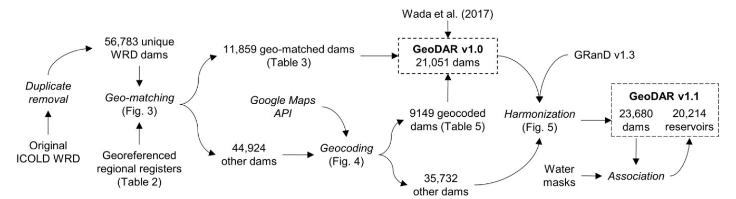
Figure 2: GeoDAR v1.0 and GeoDAR v1.1 figure 5 Georeferenced Model. Adopted from Wang et al., 2022.
As the goal is to continue refining the dataset to improve global water security, certain regions are occasionally unaccounted for, due to unavailable geo-references. Asia, for example, has an ICOLD WRD count of 23,839 dams but does not have an abundance of independent regional registers to validate the data. This leads to ongoing harmonization by using independent regional registers that accounts for multiple regions such as the ADPC Mekong dam Dataset.
Among refined registers such as Canada’s 2017 National Resource Canada (NRC), the level of confidence can be low such that only 435 locations are geo-matched dams (67%) containing 36% missing data, outliers, or in need of further referencing (Mulligan et al., 2021). This presents the need for quality assurance, which is included within GeoDAR v1.1.

Although useful, both GeoDAR v1.0 & v1.1 are limited to only large dams with 5m to 15m of hydraulic head. Hydraulic head refers to the height at which a hydraulic structure holds the potential energy of a reservoir or stream. This dataset does not account for small dams or hydropower projects that do not solely rely on large reservoirs. However, the aim at the GeoDAR datasets is to account for mid-sized dams at the mid-latitude level; however, northern regions such as Ottawa Ontario Canada or poorly governed regions such as Mekong China, there is potential for harmonization with independent datasets. As GeoDAR interpolates valuable data, regional key attributes from regional datasets are used to further the global harmonization to protect global water security (Wang et al., 2022).

3.2 Building a Region-Specific Data Harmonization Model
As GeoDAR v1.1 is to be improved on a regional basis, a standard georeferencing model by proximity aids in deduplication in the absence of available georeferenced data. One of the limitations of the GeoDAR data with respect to georeferencing is that its naming heuristics are based on projects and not locations. This is due to data limitation in certain regions. Considering GeoDAR v1.1 is the first effort in harmonizing global dam and reservoir data, not all the data sources have the same heuristics, and once compiled, georeferencing different regions requires different types of key attributes within their respective registers. For example, China, Vietnam, Thailand, Myanmar, and all regions within the Mekong Basin contain regions within “peripheral regions” of China (Ministry of Foreign Affairs of the Peoples Republic of China, N/A). Unfortunately, some of the regions in southwestern China are considered autonomous regions, thus lacking data availability, and in the event of availability, poor modes of publication are employed. Some data through searches only presented projects with specific dam types; some changed the naming conventions, such as the word “Water Gate” (Project to develop the Kam River Basin under the Royal Initiative 2013).

In examining the ADPC and GeoDAR datasets, notable projects represent one “Project_name” datapoint are at times found to contain two infrastructure projects under the umbrella term, and vis versa; thus, the accuracy of GeoDAR is reduced in regions with less reliably structured heuristics. For this reason, geo-matching data must be manual, and each region would have to be extensively searched and scraped with no guarantee of published information.

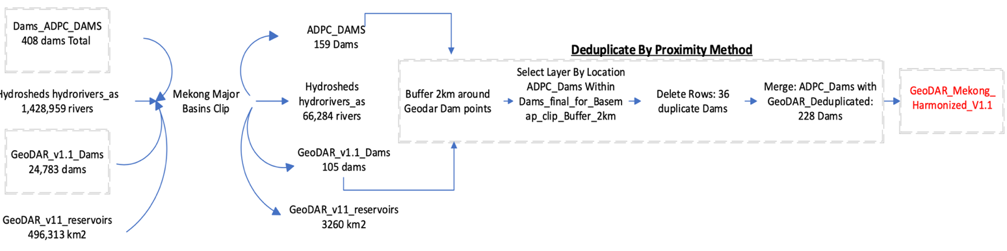
The new approach geo-matches mechanical key attributes and descriptors from GeoDAR to the reference set and is not limited to dams that are 5m-15m in height, but other types of development such as multipurpose and lower power stations. It uses GeoDAR v1.1 as a regional reference to the region's independent dataset. As the final output of GeoDAR v1.1 is further derived from digital elevation maps (DEM), referenced with reservoirs and river datasets globally, which is useful in combination with data with more useable attributes. To verify the quality of the data, additional sets such as HydroSHEDS are used to validate current accuracy by proximity to GeoDAR. By cross-validation a global dam set, river set, and regional set, the actual count is improved, as described in figure 3.
Figure 3: Deduplication & Harmonization Model for GeoDAR and ADPC Dam Data

3.3 Harmonizing GeoDARv1.1 to ADPC In the Mekong Basin
The harmonization process begins with querying the Mekong shapefile and using the clip layer tool against all the input data shown in figure 3. From this first step, 159 ADPC dams, 105 GeoDAR dams, 3260 km2 of reservoir and 66284 hydro river polylines are within the region. Due to the impedance geo-referencing in GeoDAR, a proximal analysis is performed.

The second step is to visualize the data in ArcGIS Pro and to view whether there is an abundance of duplicates, such that 36 GeoDAR dams are duplicates. Notably, there appears to be unique and unaccounted dams within both datasets, which are accounted in harmonization. To deduplicate, GeoDAR dams are selected within a 2km buffer of ADPC dams. The buffer is selected as a manual, region specific filter based on manual observation within the ArcGIS Pro environment. The buffer is derived manually by verifying 0.5 km, 1.0 km, 2.0 km, and 3.0 km buffers where the number of duplicates increased only from 0.5km and 1.0 km buffer but did not change from 2.0 km to as large as 10 km thus, 2km was selected as an acceptable range for the study. As a result of merging both dam datasets, 228 unique dams are now accounted within the region.

When merging the two files; ADPC and GeoDAR v1.1, it’s crucial to pay attention to the right merge relationship to avoid compiling encoded or interpolated data and to include the most useful attributes. For this reason, GeoDAR is harmonized with ADPC to facilitate future geocoding based on ADPC attributes. As a result, there is a 217% increase in harmonization and a 34% decrease relative to GeoDAR v1.1 in the Mekong Basin before being merged into the ADPC dam count.

3.4 Application of Harmonization Method to a New Basin Regions
With newly harmonized data within the Mekong Basin, the method can be transferred to other basin regions; in hydrologic terms, a region where water collects and drains relatively to its downstream topography. This means that in the case of the Mekong River, the flow and reservoir profile within this multi-national region, are modeled per its isolated basin profile along the Mekong River. The harmonization facilitates the accountability of the water budget, usage for various infrastructure, and can be applied and tuned to any region globally by referencing independent regional sets to continuously update GeoDAR v1.1 ad-hoc.

3.5 Automation and Improvements/packages ArcGIS
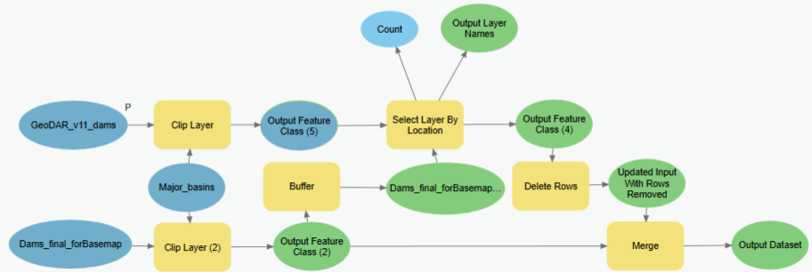
As the harmonization process is manually performed in ArcGIS Pro, much of the data exploration process and filter criteria verification occurs manually. However, ArcGIS Pro provides a Model Builder tool with ArcMap so that once processes are verified, they can be automated and transferred to other regions in the front-end graphical user interface (GUI) by changing the two input datasets as shown in Figure 4. This results in multiple automated harmonized sets to update GeoDAR v1.1 as in this case, GeoDAR_V1.1_Mekong.
Figure 4: ArcGIS Pro Model Builder for GeoDAR v1.1 in Ontario

Applying Regionally Harmonized GeoDAR Data to Determine MHP Pre-Feasibility

As GeoDAR_V1.1_Mekong presents a standard harmonization structure by proximity, a comparable region such as the Outaouais region can be reconstructed using the same deduplication by proximity model. The main difference between Mekong and the Outaouais is that the Mekong region contains overly fragmented river segments and adverse climate change, as a result making it difficult to harmoniously track developments. As Ontario is identified to be lacking a significant number of developments, specifically in the Outaouais region, harmonization entails using the Ontario Dam Inventory as the independent dataset, in turn providing the regional attributes just like the Mekong region as illustrated in Figure 2, and automated as illustrated in Figure 4.

Defining Micro-Hydro Requirements

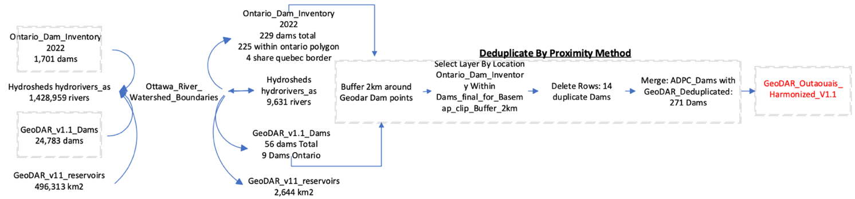
Considering the current work performed to improve GeoDAR_V1.1_Mekong, the same harmonization model is applied to the Ottawa river in the Outaouais basin region. As the filter criteria are tuned per region, the Outaouais basin follows the procedure described in Figure 4.
Figure 5: Harmonization of GeoDAR v1.1 and Ontario Dam Inventory 2022 Using Deduplication By Proximity
The model, in this case, dramatically increases the dam count in the region from 9 in Ontario and 47 in Quebec, accounting for 14 duplicates, mainly on the Ottawa river or dams near the Quebec border totaling 271 dams. The same proximity rule was employed in Mekong; however, the 0.5 km, 1 km and 2 km dam counts were identical. Unlike Mekong, the Ontario Dam Inventory accounted for in some cases, a 2 to 1 dam count. This means that for 1 GeoDAR dam, there can be two Ontario Dam Inventory points, such as the dam at Voyager Provincial Park. Whether there is a public or private dam within the vicinity, or a large 5m-15m dam, if the private data is not provided, it does not get accounted for within the dam count in GeoDAR. This presents a challenge as GeoDAR lacks georeferencing as demonstrated in the Mekong Basin. As such, the deduplication by proximity is employed and an MHP hydrogeographic analysis is then performed to determine site suitability and the micro-hydro availability footprint in the Outaouais region.

4.1.1 Micro-Hydro Economics
A multivariable weighted analysis is normally required to determine singular sites to select suitable sites. However, to produce an availability footprint, a different approach is taken to assure the feasibility of a variety of MHP, whether RoR or SHP. When evaluating micro hydro, there are solutions that meet the most specific needs for maximum power output and sustain (Jozaghi, 2018). Theoretically, only one singular turbine is needed to be sustained in order to produce power. Currently, on the market, there are a variety of turbines down to the 500-Watt range, which would not effectively produce enough power for a home, to systems of turbines as mentioned providing Megawatts of power. As Hydrotechnical development projects may require large sums of money, minimum acceptable rates of return (MAAR) are employed to establish the lower limits of financial feasibility to power output. In the case of MHP, the hydro term of return is calculated at 40 years (Renewables First, 2020). Within the 40-year payback period, the IRR, or MARR in this case, should power be consumed 100% on site is 10% for new projects and 15% for existing sites. For projects that export 100% of the electricity, it's 2% for new builds and 5% for existing’s sites, such that a typical export price is 6.5 cents per kilowatt. With these 40-year prices, which within reason is roughly 50% of the consumer price per kilowatt locally In Ontario (11.3 ¢/kwh), the minimum generation limit is 25 kW for viability (Ontario Energy Board, 2021).

4.1.2 Determining the Required Flow
The flow requirements become crucial when considering the new criteria including both RoR and SHP. For example, a single turbine producing 27 kW of electricity must have 18m of hydraulic head and a volumetric flow rate of 0.18 m3/s (Renewables First, 2020). This configuration may only be feasible for a dam; however, current river segments may already meet the requirements; notably, the Rideau River Ottawa ON flowing next to Carleton University has a class flow rate of 10 m3/s, which does support hydro-technical infrastructure. As dam projects do not solely rely on one generator, this is where RoR turbine configurations may sustainably meet the power generation requirements through flow rate and low equipotential drops in the hydraulic head.

A relationship between flow and head can be actuated such that the more gravitational-potential energy, the less intense flow is required, and vis versa for low-head hydro projects. As a result, a 25kw turbine may operate with 1.9 m3/s of volumetric flow with 2m of hydraulic head. This leads to the minimum requirements for the feasibility study to be set to 1 meter in hydraulic head (Renewables First, 2020). This value is chosen as a selecting attribute in the HydroSHEDS database, as flow rate is divided into classes by incremental order of 10. This represents as an order class of 6 to 3, representing a range between 1 and 1,000 m³/s of volumetric flow. Uniquely to HydroSHEDS, it represents data along river reach segments (Lehner et al., 2013). These polyline regions where average flow gradients are relatively uniform with respect to the segments flow. Each intersection along the continuum of a river segment represents a relative change in gradient. In the case of rivers flowing from tributaries, it may represent an increase in velocity or a region where reservoirs accumulate water to then be discharged.

4.1.3 Required Potential drop
Regarding the hydraulic head requirements, selecting suitable sites with 2m of difference in elevation in various Canadian geotechnical environments may prove difficult considering the non-conformity of natural features and obstructions along waterways of shield segments (Yang et al., 2022). As a result, finding regions of high elevation within proximity is feasible based on creating a large dam and installing a reservoir, which may adversely impact the environment and surrounding communities. Consequently, including SHP dams in a sustainable fashion would have to be such that it would conform to the same MHP RoR requirements. To best refine the site data, refining the DEM data by testing 1m to 15 m elevation difference on the topographical map left a reasonable result of 1m,2m, 5m and10 m contour lines to be used as a reference. The 10 m topographical drops within a 1 km radius of the river segment allow for sufficient hydraulic gradient to promote dams and river projects.

Reapproaching Suitable Micro-Hydro Site Selection
Historically, dam construction was determined by key physical and mechanical attributes under a decision tree matrix. Key attributes such as elevation, drainage & density, stream order, sediment transportation as well as wetness, and ground conditions are assessed and indexed proportionally to a build feasibility index. External factors such as population, power requirements, and disaster mitigation are not fully accounted for under all feasibility plans, and as such, data-driven approaches can be useful as an alternative method for determining suitable sites (Rahmati et al., 2019). However, such as the Suitable site simulator (SSS) suggests, its suitability is in this case, only intended for dams and not a broader, more specific context being MHP.

In this study, MHP contains small dams and RoR hydroelectric projects. Thus, the criteria for defining the decision matrix may not be valid across all applications. Furthermore, GIS has been proven to be entirely utilitarian in dam suitability assessments; however increasingly dependent on the input decisions relating to hydromechanical requirements, at its simplest, hydraulic head and the ability to have a consistent amount of constant water flow (Jozaghi et al., 2018). Data, however, seems to expand towards decision-making tailored to fluvial geomorphologic processes rather than population, power and irrigation requirements. As such, the number of factors in GIS systems expands in complexity and order while the weight of each input decreases relative to the latter’s importance and respective indices. This presents ever-evolving complex models that will undoubtedly exclude less attractive and less lucrative projects. Consequently, locations may in fact be suitable under poor relative conditions considering that not every project must be a dam, not every project must be meant for exponential growth, and as demonstrated in Mekong, projects may be multimodal such as having the ability to primarily be for irrigation, and either have hydroelectric potential, or the project may be ready to accommodate power generation should it be required.

While GeoDAR accounts for large dams between 5 m and 15 m of hydraulic head, SHP and MHP projects that are not dams are not accounted for, and hydro-ready facilities are also not accounted, as demonstrated at Galetta Generation station which produces 1.25 MW of Power (OWA, 2017). This disparity led GeoDAR to only account for nine dams in the province of Ontario in Canada. However, of the nine dams, six are on the Ottawa river near the national capital, producing 38 MW of power. As such, most of the power is only on the Ottawa river and not the basin in its entirety. Lessons learned from the effects of fragmenting rivers in Mekong, instead of conducting feasibility solely on weighted power requirements, using key hydro-mechanical requirements in conjunction with the geospatial harmonization allows for a hydrogeographic approach to sustainably include feasible MHP sites. In the Mekong region, the main disaster points regarding fragmentation revolve around local water access and equal resource, and disaster distribution (Harlan et al., 2021). In extreme weather events, populations located between fragmented basins or irrigation dams suffer the consequences of extreme flooding or restricted access to water, thus removing equitable access to water for a whole population. As water supply is controlled by the stakeholder owning the fragmentation process, considering the local regime, disaster is often immanent, and the idea of sustainable micro hydro projects is withered by the overbearing disaster count led by climate change and governance or imminent power requirements.

In order to avoid fragmentation and hydrogeographic disasters related to hydropower projects, as large hydroelectric infrastructure approaches decommissioning and the maintenance phase of its lifecycle, adapting the power source and irrigational needs are required, which involves environmental and flow criteria. Dams, once decommissioned, may operate as irrigation dams but may not always provide power such that as power infrastructure begins to decommission or require maintenance, implementing a safe-to-fail approach allows old infrastructure to be phased out in a sustainable low, impact manner to the participating stakeholders whether its business, consumers or government. It also promotes sustainable development testing and implementation while broadening the amount of available, viable locations in potentially remote locations.

Defining a Micro–Hydropower Footprint Using GIS in the Outaouais Basin
With basic input parameters, following transferable methodology and MHP definition, a preliminary exclusionary MHP footprint can be determined. In order to assure continuity throughout the data and MHP determination analyses, the 2km buffer used in harmonization is kept to statistically compare the change in the catchment area for available hydro rivers from the HydroSHEDS data. The analysis compares again Hydro rivers although in this case, the Outaouais basin with GeoDAR_v1.1_Outaouais and the HydroRIVERS_na_Outaouais datafile. The hydro rivers and dams are then Geo-processed to have a 2 km buffer where dams within 2km of hydro rivers are selected. Then, all hydro river segments within the 2km buffer are excluded. This is a crucial exclusion to avoid overuse and to maintain natural river hydrology. The 2km buffer is further retained as a parameter to maintain conformity and to account and exclude the average calculated river segment length of 4 km as a river segment diameter (HydroBasinv1.c, 2019).

This analysis focuses on unused hydro rivers rather than available locations to be engineered whether environmental obstructions are present. With the spatial exclusion, Figure 6 represents the data processing structure of the inverse proximity exclusion as a single dissolved HydroRIVERS buffer.

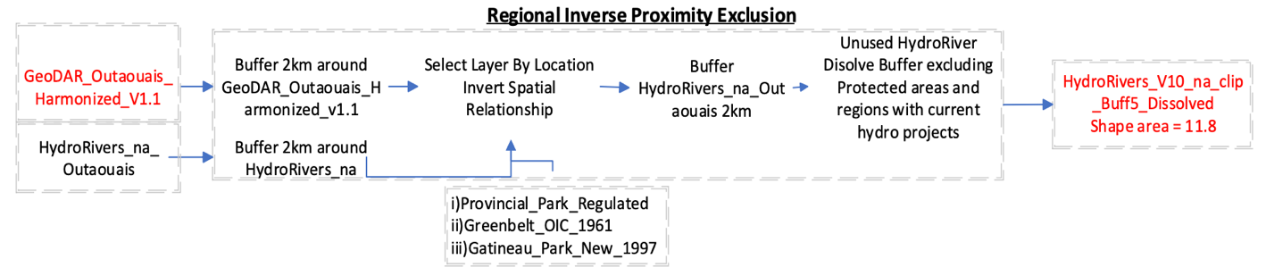
As this analysis works with interpolated data, the final shape area is unavailable as a reference within the harmonized set. Furthermore, the river segments do not contain shape areas hence the utility for river segment buffers. As a final dissolved shapefile, HydroRivers_V10_na_clip_Buff5_Dissolved provides a shape area that can be relatively compared to the final iteration of the dissolved buffer as the analysis remains consistent with the GeoDAR harmonization method. Figure 12 shows the shapefile of the catchment, which by exclusion accounts for a large region of both Ontario and Quebec in terms of MHP availability.
Figure 6: Final Regional Inverse Proximity Exclusion Model in The Outaouais Basin
This exclusionary footprint, however, only accounts for the inverse and excluded spatial relationship between dams and HydroRIVERS with control factors such as protected areas in Ontario Provincial Parks, the Greenbelt, and Gatineau Park. This region has a shape area of 11.8 (10^3) km2 and appears to largely cover the basin area. As GIS pre-feasibility utilizes watershed data, this study will use geographic-based hydromechanical data. This data is river Ord_Flow which for this iteration includes classes 3 to 6, the control factors, which are the excluded park areas, the enclosed dams, river segments, and now elevation. The elevation file used is the PDEM_South Raster file (Provincial Digital Elevation Model (PDEM), 2022).

This raster data provides a 0.5m resolution for the province of Ontario only. Unfortunately, a sufficient raster file that would account for Quebec elevations was not used in this analysis as data is unformatted and sparsely published by various hydro organizations in Quebec. Using the Raster file, the Raster to Contour function in ArcGIS Pro allows the digital raster file to be converted into a contour elevation map, specified at 10m increments in elevation changes, as depicted in the flow chart in Figure 7.
Figure 7: Micro-Hydro Sites Pre-Feasibility Model
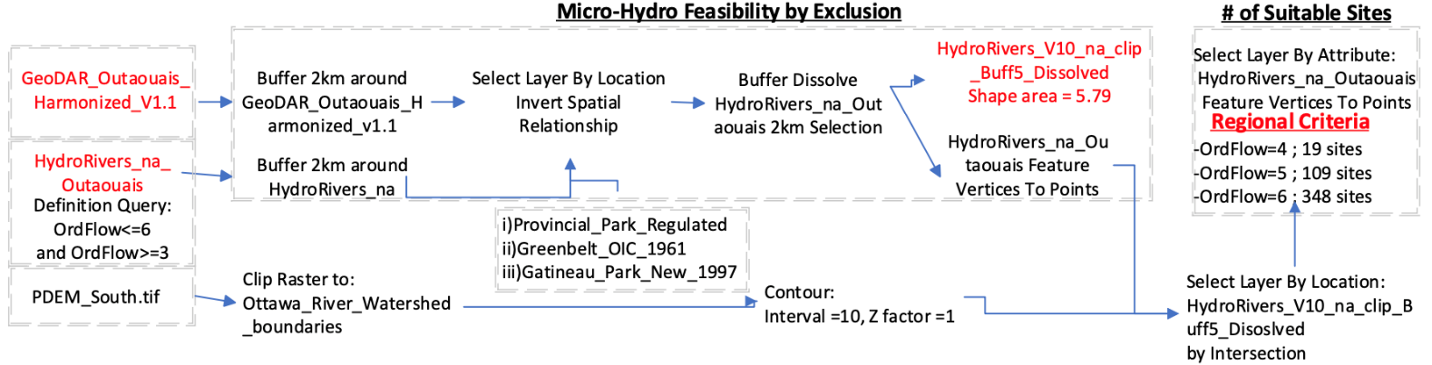
The utility of referencing contour elevations is to further refine the exclusion, but with only river segments, qualitative polyline data needs to be referenced to other polyline data. This leads to the utility of the feature vertices to points tool. As HydroSHEDS comprehensively provides river flow information, using the function at the feature vertices, it represents the river polyline data as singular points, which can further be queried to only be in locations that support the appropriate order flow of 3 to 6. Furthermore, inflection points on the polyline towards the lower-class Ord_Class segments are selected by proximity to the river’s intersection of the polyline data (Lehner et al., 2013).

Of the polylines selected, specific inflection locations of this criteria uniquely represent 476 viable MHP locations, whether it’s a dam or a run of the river project. To depict the river count by shape area, the value 5.79 (10^3) km2 represents a 51% decrease in the catchment area for available hydro rivers to support MHP. Within the catchment, of the 476 sites, 19 are along rivers with 100 m³/s, 109 are along ten m³/s, and the latter, 348 sites are along segments of 1 m³/s, as demonstrated in Figure 7.

The available dam data: however, only accounts for sites in Ontario where the catchment represents available data in the whole region of the Outaouais basin. This catchment shape area is 1.383(10^3) km2, being 23.8% of the basin’s available hydro rivers for MHP. This also entails that the total useable shape area for suitable MHP sites within the Outaouais basin is 11.7% of the total exclusionary footprint. This suggests the results of the methodology present available hydro rivers in the basin but only symbolize potential MHP locations as a function of the DEM intersection with the Ontario data.

Discussion

5.1 Geospatial Results in Harmonizing GeoDAR V1.1
5.1.1 Data Relevance
The GeoDAR_v1.1_Mekong dataset represents a harmonization process by merging GeoDAR v1.1 with the regional ADPC dam dataset. In harmonizing the datasets, the main utility of selecting GeoDAR as the sacrificial set for row deduplication is that it increases the number of useable attributes for future use as opposed to vis versa. For this reason, GeoDAR is merged to ADPC to create the new GeoDAR dataset, in turn reducing the number of encoded attributes while keeping the data relevant to the micro-hydro application.

Initially, the hypothesis for this study involved performing inner and outer joins iteratively to harmonize the dataset based on key attributes such as name and place location. However, the data uses different conventions, such as project name. The project naming heuristic, although useful, does not fully represent the volume in the data count. As demonstrated in Figure 8, there is an overlap between the datasets such that 1:2 and 2:1 dam count ratio is present between the datasets. When performing geocoding operations in the Mekong Basin, the lack of data prevents specific geocoding and reverse geocoding. Even with the specific, potentially geo-referenceable locations found on Google Maps, they remain unassociated with the on-site infrastructure projects, or data collection convention; thus, reverse geocoding becomes redundant for this application.

Ideally, the most effective geocoding method would harmonize all data based on the project name and not but not the key attributes georeferencing key attributes.
To solve incompatible heuristics, applications of specific interpolated criteria allow for the use of control variables to be used, in the case of this study, a 2km buffer radius around suitable locations. This assures quality assurance and processing ease for geoprocessing dam point data while providing a small map region to analyze smaller amounts of data. In the case of GeoDAR, key attributes involve a variety of reference data and (X, Y) coordinates. These coordinates; however, are based on extrapolated data from the GeoDAR v1.0 datasets.

5.1.2 GeoDAR v1.1 Harmonization Results
As GeoDAR is one of the first global initiatives to account for dam inventories through attributes by harmonizing reservoir and their mechanical properties, using this correct, and validated data against reliable independent sources containing mechanical data enhances the utility of GeoDAR (Wang et Al. 2022). For this reason, the proximity by deduplication method is employed such that the 2:1 ADPC: GeoDAR relationship is employed and further ensures that the project name heuristic does not account for multiple stations in one project or site. Alternatively, the 1:2 count ratio between the two files indicates that there presents inconsistency such that data is missing from GeoDAR. For this reason, applying the 2:1 method to ADPC allows for instances where 2:1 does not deduplicate unique data points. Furthermore, the method by proximity is selected due to the abundance of 2:1 cases. In Mekong, there are 36 duplicates, of which there are fewer duplicates when GeoDAR is selected to ADPC due to the 1:2 relationship on occasion.

After manual quality assurance, it is determined that the best methodology is to deduplicate by proximity. In Mekong's case, a 2 km buffer is selected as an appropriate distance between reservoir and dam locations such that no unique values are deleted. In performing manual quality checks, 0.5 km contained 32 sites, 1 km contained 34 sites, and the latter within reason contained 36 sits between 2 and 5 km radii. As a result, 36 sites from ADPC were deduplicated from the original 159 dam locations within the Mekong basin, and the file was merged with GeoDAR_V1.1_Mekong, containing 105 sites then producing a harmonized count of 228 dams. This methodology is verified manually and semi-automated in the ArcGIS Pro environment using the Model builder and can be replicated in any region, provided independent datasets.
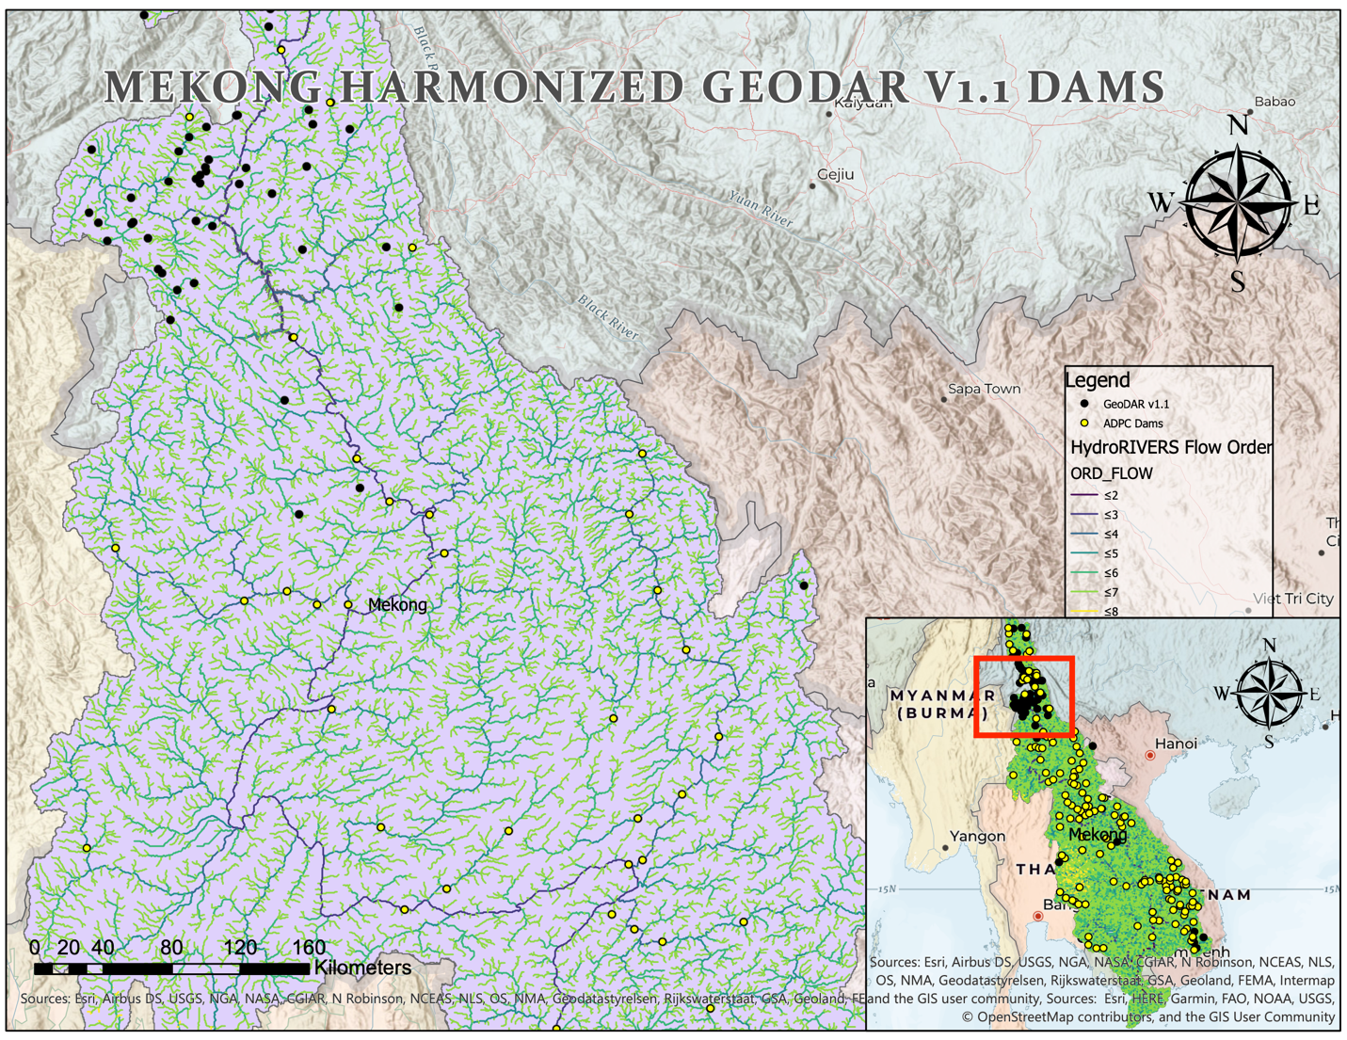
Figure 8: ADPC and GeoDAR Dams
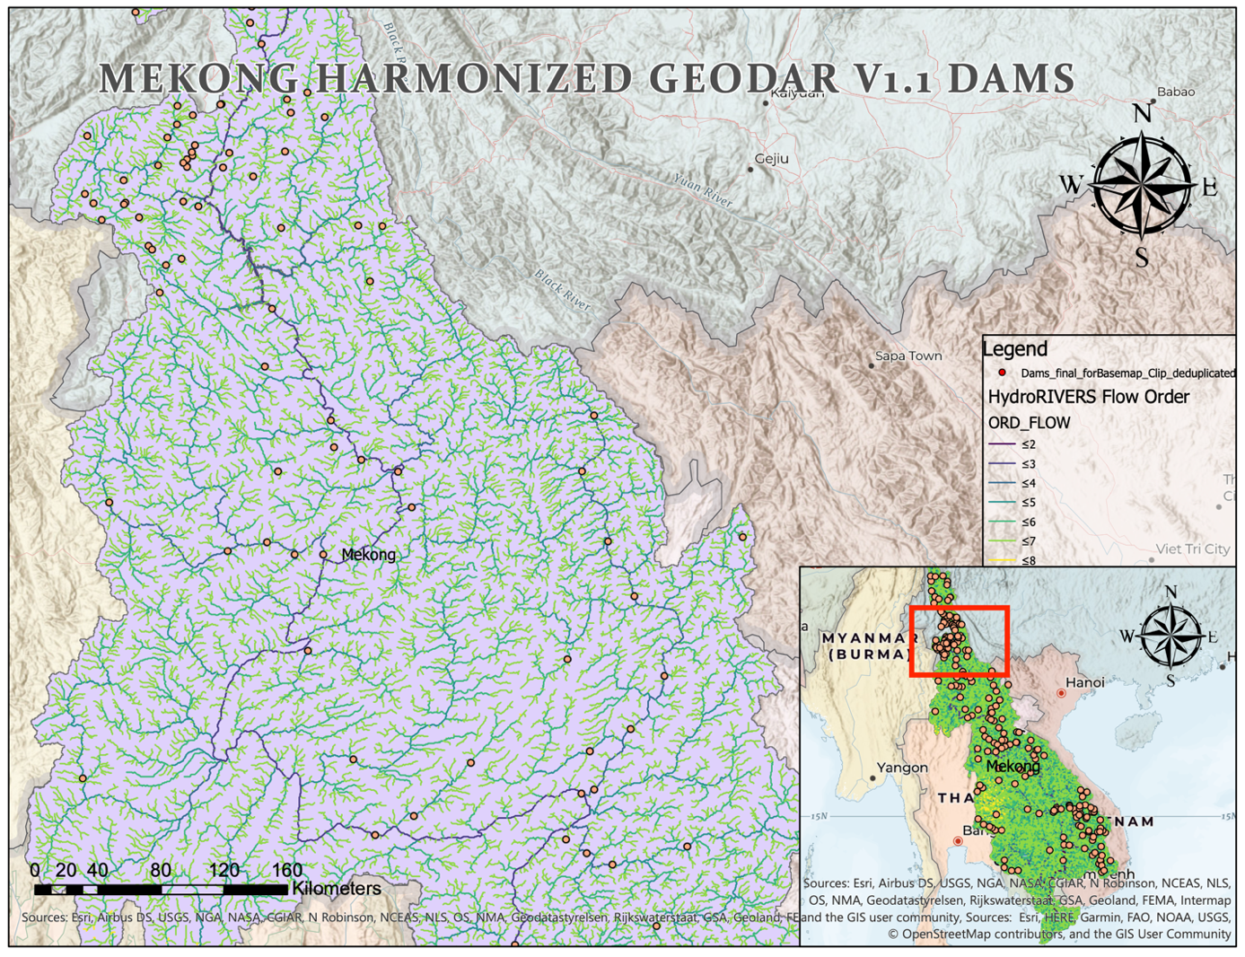
Figure 9: GeoDAR Harmonized Dataset Along the Mekong Basin
5.1.3 Methodological Utility
In measuring the accuracy of the GeoDAR data, the HydroSHEDS data file is employed as both a referenced and join data file. As the GeoDAR shapefile presents dam location data harmonized with ADPC data, it incorporates flow and ID and catchment data and discharge flow characteristics of the region (Lehner et al., 2013). HydroSHEDS is used as a reference dataset in harmonizing GeoDAR, but also a control variable in the micro-hydro feasibility analysis. In analyzing the requirements by buffer, comparing the catchment shape area of dissolved buffers allows for the overall process improvement to be compared relatively by catchment buffer.

In this case, buffer catchment is a useable control variable in which catchment data is be relatively analyzed on a common buffer value, in this case, the same 2km radius from the harmonization process. In doing so, two different types of data can be visualized: the exclusionary data per the harmonization analysis and dam the buffer footprint, a measure of excluded rivers within 2km of a dam site. This control variable allows for future multivariable analysis, such as topographical analysis within the control region. It also promotes small-scale computation, whether the back end with data sets or the front end in the ArcGIS user API.

In the case of the deduplication by proximity, the first step in the harmonization process is to buffer all GeoDAR Dam sites within the shapefile as one buffer layer. Using this buffer, the select layer by location tool is used to select the HydroRIVERS within the GeoDAR dam buffer layer. The spatial inversion tool is then employed to select all rivers that are not within the buffer area. In doing so, a reasonable amount of HydroRIVERS is excluded from the selection by selecting the rows of the GeoDAR file within, again, a 2km buffer region around ADPC Dam locations. This method, as previously indicated, represents 36 dam sites.

5.2 Micro-Hydro Suitability Results
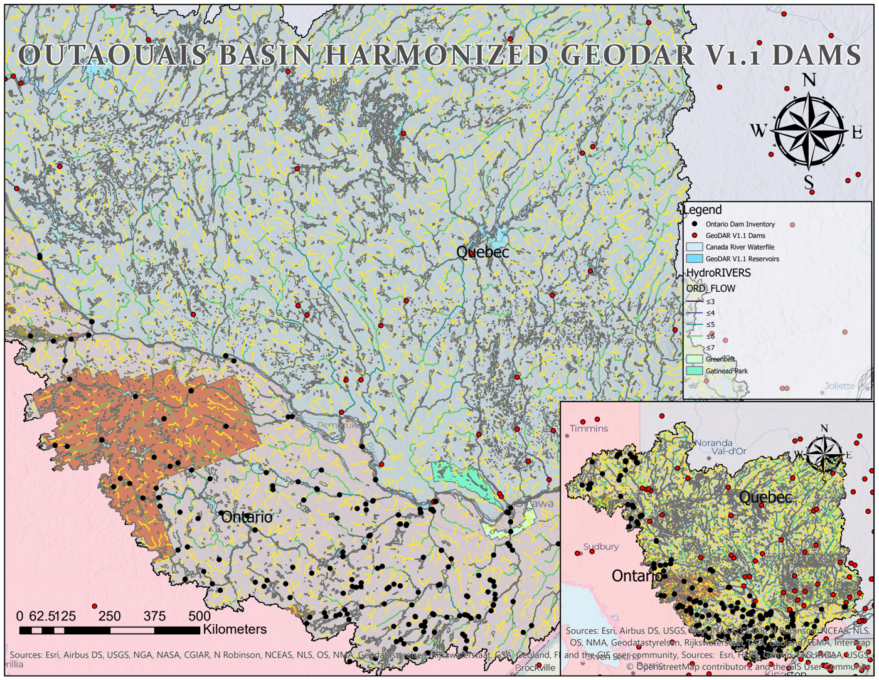
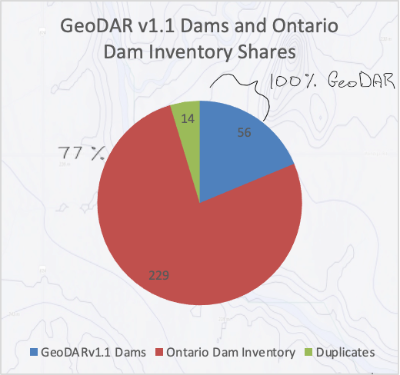
In reproducing harmonized datapoints to produce the dissolved buffer map along the Outaouais basin as shown in Figure 12, there only presented 14 duplicates within the Outaouais basin. GeoDAR presents nine dam sites within Ontario, and 220 in Quebec, while four sites share the provincial border. This provincial border presents duplication errors as data can be reported within each respective province, then aggregated within the ICOLD and GRaND datasets, which would incur and demonstrate the 2:1 relationship. It also presents data inconsistencies within Ontario, considering that there are most definitely more than nine dams in the 1.076 million m³ reservoir capacity. Using the catchment and the deduplication/harmonization process, a total of 71 dam locations are identified where GeoDAR contained 56 dams, and the new Ontario Dam Dataset contains 229 sites (Ontario Dam Inventory, 2022). This refinement in this region presents an increase in count total by 484%. Considering the manual results, the semi-automated model builder results reproduce the process while yielding the same results, thus validating the utility of the method.
Figure 10: GeoDAR and Ontario Dam Inventory Before Geoprocessing
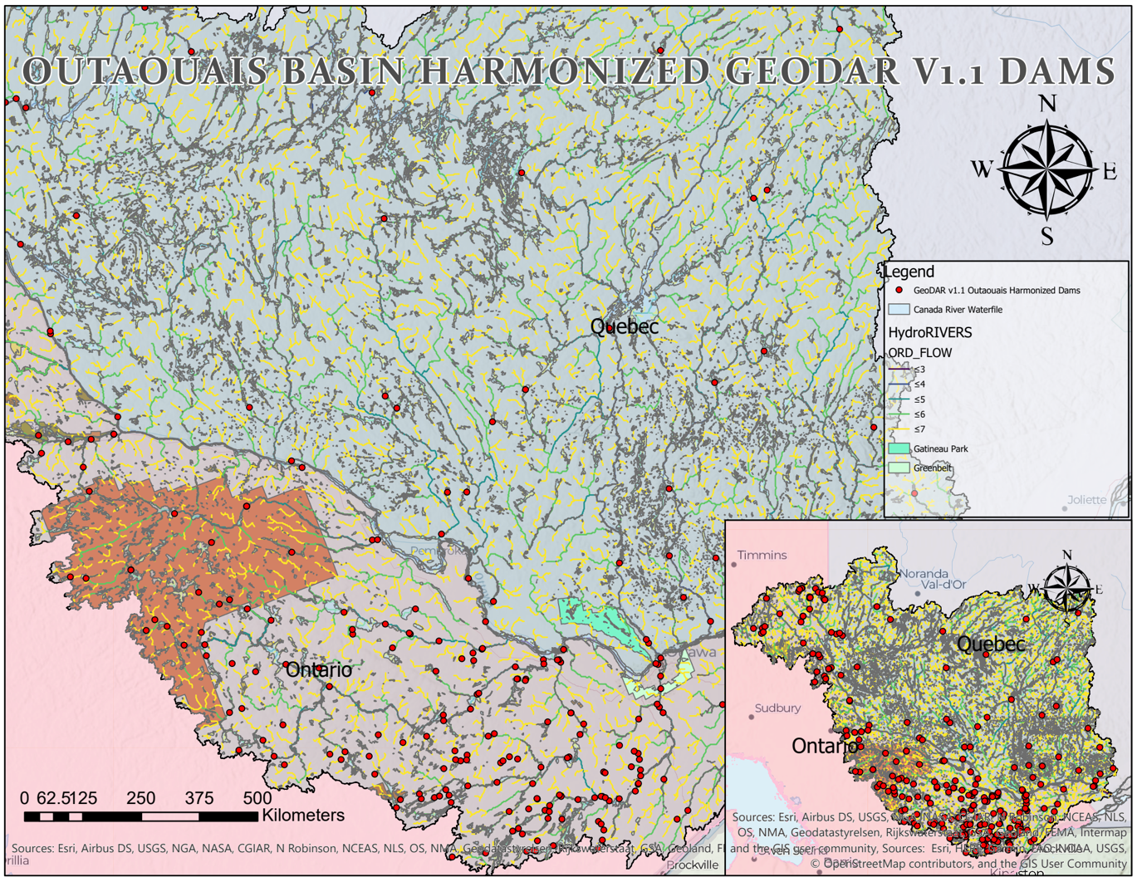
In comparing the feasibility of the dam set before and after adding further exclusion filters, the shape area, 11.8, is refined to 5.79, thus demonstrating a 49% decrease in suitable rivers by count. From the first iteration to the second in refining the count and producing the footprint, adding flow criteria, and excluding protected areas resulted in this 49% decrease in the count. Further factors may be added per application to refine the available hydro river footprint and, in turn, suitable dam locations.
Figure 11: GeoDAR V1.1 Outaouais Harmonized Data
Figure 12: Share of GeoDAR v1.1 and Ontario Dam Inventory in GeoDAR_v1.1_Outaouais_Harmonized
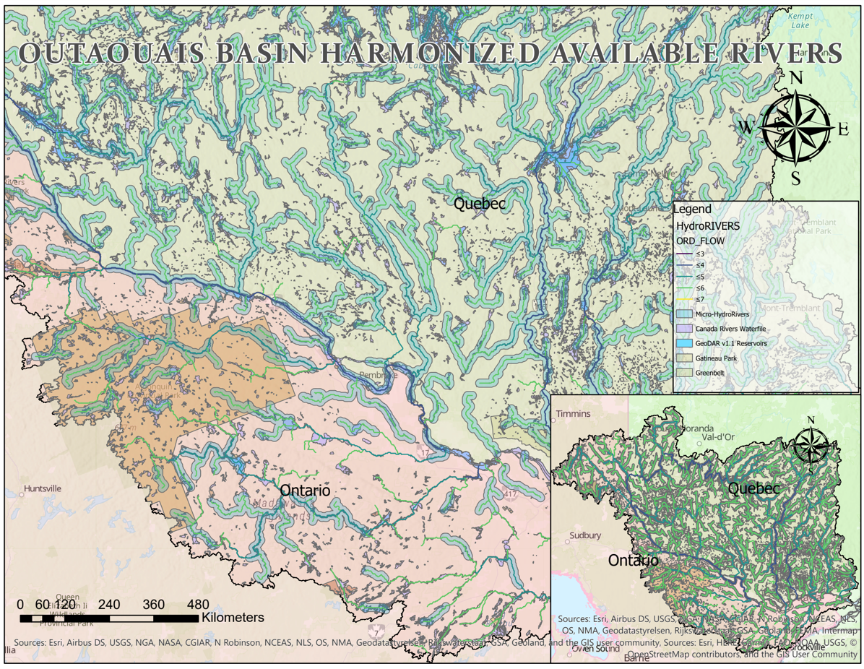
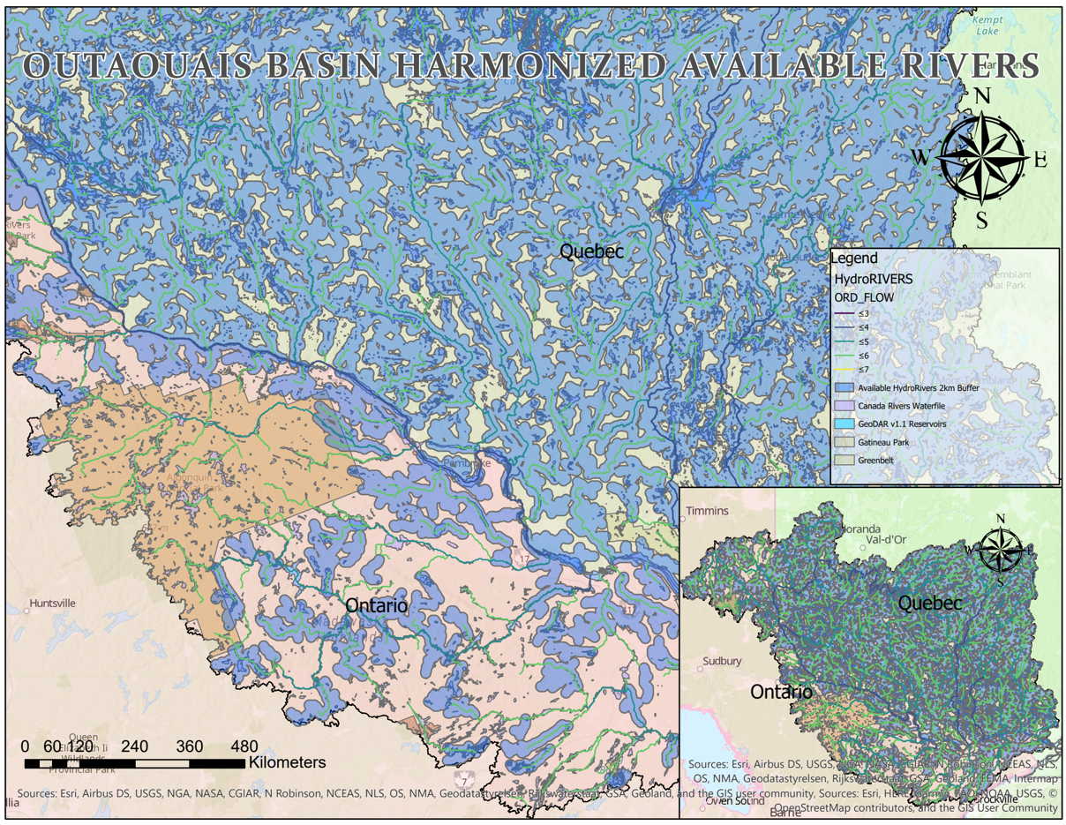
Figure 13: Inverse Dam Region Spatial Relationship with Utilized River Segments
Figure 14: Available Hydro River Buffer Region Around Adequately Flowing River Segments
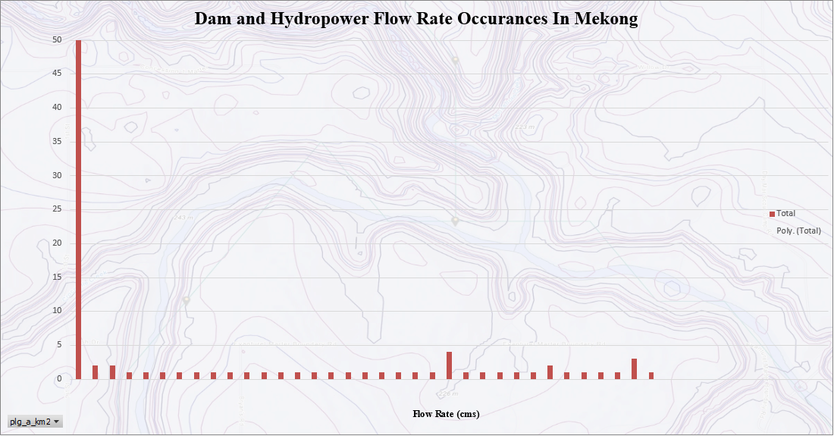
Having produced both the data and geography for the study, the count of dams subject to specific flow rates indicate the potential of both SHP and RoR. With an updated buffer map for both regions regarding the total hydro developments, the dam count is increased to 228 dams along the Mekong Basin and 271 in the Outaouais basin. The catchment area of the GeoDAR reservoirs is a parameter which can be used to verify the quality of the data. As GeoDAR accounts for of reservoir area in km², and ADPC has its own attributes for the same data, comparing the sum of the area part of the harmonization allows for verification of the reservoir capacity as the relative count increases.
Figure 15: Dam Count by Increasing Flow Rate
The total GeoDAR reservoir within the Mekong Basin catchment accounts for 3,260 km2 and once the ADPC data is deduplicated and merged with the GeoDAR data within the same region, the ADPC portion of the Merged catchment represents a 94% accuracy such that 3079 km2 is accounted. While 36 GeoDAR dams were deduplicated to harmonize useable ADPC data, only the ADPC dam data points provide reservoir statistics while GeoDAR references multiple types of datasets I.E dams and reservoirs. As a result, although 94% of the reservoir catchment is obtained relative to the original GeoDAR Reservoirs catchment, this only accounts for 123 sites, 54% of the total harmonized count. This presents room for improving the reservoir data as not all the existing locations are attributed to dam or RoR hydro projects. With 47% of the source of hydropower unaccounted in Mekong, this may present a catchment-based opportunity to improve reservoir data to best determine the remaining available water reservoirs.

Nevertheless, with the current set of potential micro-hydro locations from replicating the method from the Mekong basin to the Outaouais Basin, 19 sites at a flow order of 4, 109 sites at a flow order of 5, and 348 sites were found at a flow order of 6. A flow order of 4 is equivalent to 100 m3/s; five is equal to 10m3/s, and six is equivalent to 1m3/s. In comparison to the harmonization in Mekong, 55% of dams constructed as demonstrated in the Mekong basin represent a flow order of 0.005 m3/s to 1m3/s.
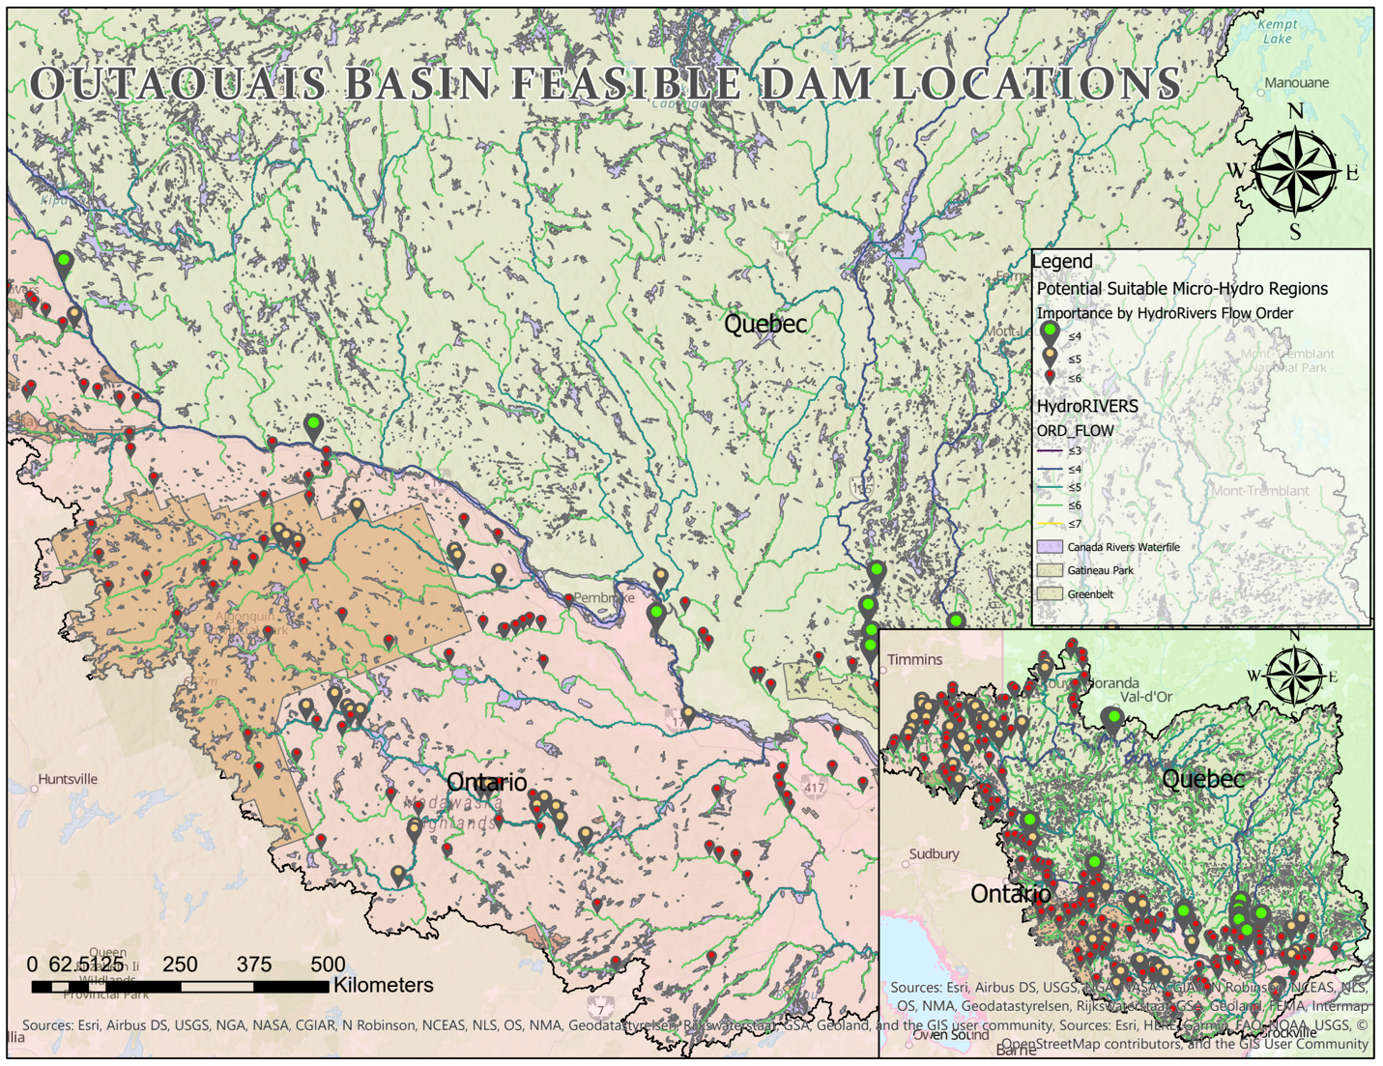
This indicates that low flow order hydropower dams built on reservoirs currently dominate the market share relative to high flow hydropower plants. Due to GeoDAR’s lack of dam information in Ontario, this can also be reflected through the dam site suitability count in the Outaouais region, such that 19 suitable sites equate to 4% of the suitable for high flow streams, 23% for medium suitability in order flow 5, and 73% accounting for low flow streams. The common trait is that low-flow rivers are more suitable, demonstrated in the built infrastructure. However, low flow MHP requires 0.38 m3/s, which is met throughout the methodology and accounts for 55% of the low flow sites, but low head MHP must require a minimum 1.9 m3/s flow to produce the minimum feasible power, 25 kW.
Figure 16: Final Micro-Hydro Pre-Feasibility Study

Considering the number of locations provided, a total potential considering the minimum power output to count ratio, 11.9 Megawatts of power is available within the current undisturbed hydro rivers with Micro-hydro power only. The MHP map interactively presents the average locations such that the point selection is based on the inflection point of hydro river polylines; thus, the 2km buffer along with the 2m DEM data provides a preliminary assessment for determining suitable locations. Considering existing multivariable analyses that further refine the count to specific locations of suitability, including factors such as human factors and economics, further factors are indexed and weighed against one another to fully refine site selection. (Jozaghi et al., 2018). This study refines the hydro river to dam availability and supports the methodologies in GIS feasibility by providing a footprint and not a specific location such that if a dam location is not suitable or requires a preliminary study to refine the available areas, this study may aide in excluding redundant sites without specifically a mode of power generation.

Regarding the Ontario catchment, 2,664 km2 of GeoDAR catchment is also provided, however, no shape data is available. For this reason, the data harmonization by inverse exclusion is utilized as its primary purpose is to exclude unsuitable locations using basic parameters such as tributaries flowing within 2km of the dam. Instead of input parameters matching criteria, the reverse is in effect such that exclusionary parameters are used, and in this case, georeferencing HydroRIVERS flow to suitable, excluded hydro rivers from the current dam inventory in the Outaouais Basin.

5.3 Limitations & Potential Applications and Further Work
As GeoDAR is harmonized for its count where some key attributes are encoded, referencing spatial inventories such as HydroSHEDS and local datasets promote spatial interpolation to produce useful data, and in this case, the application. Limitations of this proximity method involve regional hydrologic constraints such as the proximity and profile of each river basin. For this reason, the filtering criteria must be manually verified, then employed in the methodology. Deduplicating by proximity may incur errors in a 2:1 duplicate dataset relationship thus, manual quality assurance must be applied to avoid deleting useful and unique data. 1:2 deduplication does not present an issue, however, identifying the correct dataset to sacrifice its rows is crucial. In this case, GeoDAR was sacrificial to Ontario Dams and ADPC datafiles because it contained the most encoded key attributes. To utilize encoded data, using appropriately verified data is necessary to produce useful results. Limitations are primarily present in reverse geocoding and geocoding as dam locations are not always places within referenced APIs such as Google. Furthermore, without proper location data, environmental data is used to interpolate geolocated data, and as a result, the findings will be tailored to the most referenceable mechanical data such as flow rate, CMS, catchment area, and discharge. Future considerations in standard data collection and heuristics regarding key attributes will be required for further research. Furthermore, to automate the process in the model builder, using the deduplication by proximity allows for the manual quality assurance to be completed before geoprocessing, whereas GeoDAR iteratively performed quality assurance and assigned levels of QC/QA. Further automation within the manual QC/QA process will involve further harmonization of environmental key attributes to render the location or naming data referenceable to the current GeoDAR dataset.

However, with the harmonization accuracy by refining regional dam count, the inverse relationship between the dam’s 2km buffer and available queried HydroRIVERS produces an MHP footprint. However, to begin automating the process, further geographic factors are to be considered, such as valley potential, flood potential, and key information which further refines the potential locations.

As the HydroSHEDS data presents extrapolated polylines from DEM and flow data, the river polylines often intersect many bends and elevation differences in the river as they do not represent the rivers shape, hence the use of the Rivers Waterfile dataset for map visualization. A polyline segment represents the average gradient of a river segment and separates the segments by a change in average gradient. For this reason, the MHP feasibility model includes a 2km buffer, not only to maintain the buffer as a control variable but to visualize the intersection between elevation contour lines. As suitable available river segments intersect suitable hydraulic elevations, the polyline is then Geo-processed to visualize the points of inflection, as well as the data associated with the HydroRIVERS polyline as one suitability marker. The suitable river points are displayed as suitable dam locations in with descriptive attributes such as flow order. This presents general inflection areas of interest along a river polyline with respect to flow attributes. The downside is that due to referencing extrapolated datasets, it lacks spatial resolution such that an interpolated polyline may not represent bends and elevation drops within a segment as a topographic map would represent. Furthermore, the river segments do not always align with the current stream hydrology; thus, its pre-feasibility must then be determined qualitatively or be used as a reference for further feasibility studies. However, as an MHP footprint, this map data may be further explored through applications such as field maps, where empirical site data and site-specific studies may be conducted to fully determine the suitability.

Conclusion
Within the study, GeoDAR v1.1 is spatially referenced, and harmonized using two independent regional datasets; Mekong Basin and the Outaouais Basin. Considering the challenges in reverse geocoding projects, a deduplication by proximity methodology is employed to improve GeoDARs dam count from 105 to 159 locations within the Mekong Basin, and 56 to 271 dams within the Outaouais basin. In the case of the Outaouais basin, only data from Ontario Dam Inventory are harmonized due to a lack of available Quebec datasets. In evaluating the data from the methodology, key metrics such as catchment area and flow rate are used to determine the site suitability. In the harmonized Mekong dataset, the reservoir’s newly joined catchment attribute is compared to the GeoDAR Reservoirs dataset resulting with a harmonized reservoir catchment of 3, 079 km², stemming from the ADPC data, and a 3,260 km² from GeoDAR v1.1 Reservoirs dataset. Although it may seem the data is converging towards the GeoDAR Reservoirs data catchment of 3,260 km², however the catchment of 3,079 km² only accounts for 54% of the harmonized data, stemming from the ADPC dataset. This indicates a need for further improvement of the updated dataset.
The harmonization process along the Ottawa river however does not require the reservoirs to be verified in this study as the Ontario Dam Inventory accounted for 20% of the total dams within the Outaouais basin. This indicates that the GeoDAR v1.1 dam dataset has room for improvement in matching regional reservoir and dam inventories in Ontario and Quebec.

In application, the inverted spatial analysis of the tributaries within 2km of each dam location provides a buffer zone and control variable to determining suitable sites. Using the harmonized dam dataset, all river segments whose 2km buffers intersect the harmonized dam buffers are excluded, and an undisturbed hydro river footprint is produced, producing a shapefile of 11.8. This shapefile is refined using flow orders equating to 1m³/s to 100m³/s, producing a shape area of 5.79, presenting a 49% decrease in shape area. The decrease in available area is referenced with a regional raster DEM dataset to elevation contours to in the end produce 476 suitable micro hydro regions. Of the 476, 19 are highly suitable, 109 are suitable, and 348 meet the minimum requirements.
As the study involved innovating to improve the data, in turn applying it to determining MHP sites, this site pre-feasibility presents one perspective in determining the available power generation options related to hydropower in a sustainable manner. It also promotes safe to fail infrastructure by providing a broad regional dataset providing multiple potential generation facility locations. This can aide in reducing power dependencies on large non environmentally friendly generation facilities and future applications of this data could involve electrifying roads and rural areas with hydropower potential, reinforcing the aging infrastructure by providing support to the grid with diverse power assets.

DISCLAIMER: This study is intended for Carleton University’s Geom4005; Undergraduate Directed Study in Geomatics with Dr. Kevin Hamdan, and in partnership with United Nations University Professor Dr. Charlotte Macalister to provide data innovation for the INWEH project while using the data in geospatial applications to produce a directed study in geomatics. This study is the property of Carleton University and may not be used for business purposes. The provided GeoDAR v1.1 is proprietary data whose distribution is prohibited and whose accuracy is independent of the study. Datasets such as HydroSHEDS, Ontario Dam Inventory and subsequent map layers are not produced by the study, and as a result the findings pertain to the geospatial constraints of the datasets.

Acknowledgements
The study provides an introductory geospatial analysis in the ArcGIS Pro environment and exercises data provided by Dr. Charlotte Macalister from the UNU-INWEH. May thanks be extended to Dr. Kevin Hamdan from Carleton University and Dr. Charlotte Macalister for their guidance in providing the opportunity to perform this study as well as the data providers such as Dr. Jida Wang from the University of Kansas State, ICOLD, GranD, GOOD, HydroSHEDS, Ontario GeoHub Library of datasets and ADPC for providing accurate up to date data that may not all be available to the general public.

References
J. Wang, B. A. Walter, F. Yao, C. Song, M. Ding, A. S. Maroof, J. Zhu, C. Fan, J. M. McAlister, S. Sikder, Y. Sheng, G. H. Allen, J.-F. Crétaux, and Y. Wada, “Geodar: Georeferenced global dams and reservoirs dataset for bridging attributes and geolocations,” Earth System Science Data, 21-Apr-2022. [Online]. Available: https://essd.copernicus.org/articles/14/1869/2022/. [Accessed: 29-Jul-2022].
“Data,” Global Dam Watch, 23-Jan-2020. [Online]. Available: http://globaldamwatch.org/data/#core_global. [Accessed: 29-Jul-2022].\
J. Wang, B. A. Walter, F. Yao, C. Song, M. Ding, A. S. Maroof, J. Zhu, C. Fan, J. M. McAlister, M. S. Sikder, Y. Sheng, G. H. Allen, J.-F. Crétaux, and Y. Wada, “Geodar: Georeferenced global dams and reservoirs dataset for bridging attributes and geolocations,” Zenodo, 01-Apr-2022. [Online]. Available: https://zenodo.org/record/6163413#.YsUIJezMIjg. [Accessed: 29-Jul-2022].
“Servir-Mekong - servir.adpc.net.” [Online]. Available: https://servir.adpc.net/sites/default/files/public/publications/attachments/FS_SERVIR-Mekong%20%28R1%29_0.pdf. [Accessed: 29-Jul-2022].
“What is modelbuilder?,” What is ModelBuilder?-ArcGIS Pro | Documentation. [Online]. Available: https://pro.arcgis.com/en/pro-app/2.8/help/analysis/geoprocessing/modelbuilder/what-is-modelbuilder-.htm. [Accessed: 29-Jul-2022].
Sjolster31Sjolster31 9911 silver badge77 bronze badges and HornbyddHornbydd 39.4k55 gold badges3636 silver badges7878 bronze badges, “How to split multiple lines of the same feature using a line?,” Geographic Information Systems Stack Exchange, 01-Nov-1963. [Online]. Available: https://gis.stackexchange.com/questions/193020/how-to-split-multiple-lines-of-the-same-feature-using-a-line. [Accessed: 29-Jul-2022].
E. Studios, “What is a digital elevation model (DEM)? A practical guide.,” Equator, 12-Nov-2021. [Online]. Available: https://equatorstudios.com/what-is-a-digital-elevation-model-dem. [Accessed: 29-Jul-2022].
“Feature vertices to points (data management),” Feature Vertices To Points (Data Management)-ArcGIS Pro | Documentation. [Online]. Available: https://pro.arcgis.com/en/pro-app/2.8/tool-reference/data-management/feature-vertices-to-points.htm. [Accessed: 29-Jul-2022].
J. Harbaugh, “Servir-Mekong,” NASA, 25-Aug-2015. [Online]. Available: https://www.nasa.gov/mission_pages/servir/mekong.html. [Accessed: 29-Jul-2022].
“The Infrastructure Trolley Problem: Positioning safe‐to‐fail ...” [Online]. Available: https://agupubs.onlinelibrary.wiley.com/doi/10.1029/2019EF001208. [Accessed: 29-Jul-2022].
“Little impact of the Three Gorges Dam on recent Decadal lake decline ...” [Online]. Available: https://agupubs.onlinelibrary.wiley.com/doi/10.1002/2016WR019817. [Accessed: 29-Jul-2022].
B. Paredes-Beltran, A. Sordo-Ward, and L. Garrote, “Dataset of georeferenced dams in South America (DDSA),” Earth System Science Data, 02-Feb-2021. [Online]. Available: https://essd.copernicus.org/articles/13/213/2021/. [Accessed: 29-Jul-2022].
M. Mulligan16, B. Lehner2, C. Zarfl3, M. Thieme4, P. Beames2, A. van Soesbergen1, J. Higgins6, S. R. Januchowski-Hartley7, K. A. Brauman8, L. D. Felice9, Q. Wen9, C. G. de Leaniz7, B. Belletti11, L. Mandle12, X. Yang13, J. Wang14, N. Mazany-Wright15, M. T. https://orcid.org/0000-0003-3216-9129, A. van S. https://orcid.org/0000-0002-3263-4011, S. R. J.-H. https://orcid.org/0000-0002-1661-917X, K. A. B. https://orcid.org/0000-0002-8099-285X, L. D. F. https://orcid.org/0000-0003-0549-2123, X. Y. https://orcid.org/0000-0002-0046-832X, and J. W. https://orcid.org/0000-0003-3548-8918,
“IOPscience,”Environmental Research: Infrastructure and Sustainability, 15-Oct-2021. [Online]. Available: https://iopscience.iop.org/article/10.1088/2634-4505/ac333a. [Accessed: 29-Jul-2022].
F. Yassin, S. Razavi, M. Elshamy, B. Davison, G. Sapriza-Azuri, and H. Wheater, “Representation and improved parameterization of reservoir operation in hydrological and land-surface models,” Hydrology and Earth System Sciences, 17-Sep-2019. [Online]. Available: https://hess.copernicus.org/articles/23/3735/2019/. [Accessed: 29-Jul-2022].
“Report on climate smart disaster risk reduction interventions in agriculturesector - flood hazard,” Asian Disaster Preparedness Center. [Online]. Available: https://www.adpc.net/igo/contents/Publications/publications-Details.asp?pid=1578. [Accessed: 29-Jul-2022].
O. Rahmati, Z. Kalantari, M. Samadi, E. Uuemaa, D. D. Moghaddam, O. A. Nalivan, G. Destouni, and D. Tien Bui, “GIS-based site selection for check dams in watersheds: Considering geomorphometric and Topo-hydrological factors,” MDPI, 13-Oct-2019. [Online]. Available: https://www.mdpi.com/2071-1050/11/20/5639/htm. [Accessed: 29-Jul-2022].
A. Jozaghi, B. Alizadeh, M. Hatami, I. Flood, M. Khorrami, N. Khodaei, and E. Ghasemi Tousi, “A comparative study of the AHP and Topsis techniques for dam site selection using GIS: A case study of sistan and Baluchestan Province, Iran,” MDPI, 17-Dec-2018. [Online]. Available: https://www.mdpi.com/2076-3263/8/12/494/htm. [Accessed: 29-Jul-2022].
“Hydro return on Investment - Renewables first,” Renewables First - The Hydro and Wind Company, 31-Oct-2019. [Online]. Available: https://www.renewablesfirst.co.uk/hydropower/hydropower-learning-centre/what-would-the-return-on-investment-be/. [Accessed: 29-Jul-2022].
“What minimum head and flow do I need? - renewables first,” Renewables First - The Hydro and Wind Company, 24-Mar-2016. [Online]. Available: https://www.renewablesfirst.co.uk/hydropower/hydropower-learning-centre/what-is-the-minimum-head-and-flow-i-need/. [Accessed: 29-Jul-2022].
V. S. Milner, S. M. Yarnell, and R. A. Peek, “The ecological importance of unregulated tributaries to macroinvertebrate diversity and community composition in a regulated river - hydrobiologia,” SpringerLink, 01-Dec-2018. [Online]. Available: https://link.springer.com/article/10.1007/s10750-018-3840-4. [Accessed: 29-Jul-2022].
S. Jumani1, M. J. Deitch2, D. Kaplan3, E. P. Anderson4, J. Krishnaswamy5, V. Lecours6, M. R. Whiles1, and S. J. https://orcid.org/0000-0002-2292-7996, “IOPscience,” Environmental Research Letters, 14-Dec-2020. [Online]. Available: https://iopscience.iop.org/article/10.1088/1748-9326/abcb37. [Accessed: 29-Jul-2022].
S. Jumani, M. J. Deitch, D. Kaplan, E. P. Anderson, J. Krishnaswamy, V. Lecours, and M. R. Whiles, “River fragmentation and flow alteration metrics: A review of methods and directions for future research,” Environmental Research Letters, vol. 15, no. 12, p. 123009, 2020.
“WWF-Canada.” [Online]. Available: http://awsassets.wwf.ca/downloads/canadas_rivers_at_risk.pdf. [Accessed: 29-Jul-2022].
“Hydroelectric Power Plant,” Hydroelectric Power Plant - an overview | ScienceDirect Topics. [Online]. Available: https://www.sciencedirect.com/topics/earth-and-planetary-sciences/hydroelectric-power-plant. [Accessed: 29-Jul-2022].
“Data Portal,” MRC. [Online]. Available: https://portal.mrcmekong.org/monitoring/river-monitoring-telemetry. [Accessed: 29-Jul-2022].
Y. Wada, M.-H. Lo, P. J.-F. Yeh, J. T. Reager, J. S. Famiglietti, R.-J. Wu, and Y.-H. Tseng, “Fate of water pumped from underground and contributions to sea-level rise,” Nature News, 02-May-2016. [Online]. Available: https://www.nature.com/articles/nclimate3001. [Accessed: 29-Jul-2022].
“Ministry of Agriculture, Food and Rural Affairs,” Micro-Hydro Systems. [Online]. Available: http://omafra.gov.on.ca/english/engineer/ge_bib/micro.htm#2. [Accessed: 29-Jul-2022].
J. I. Razan, R. S. Islam, R. Hasan, S. Hasan, and F. Islam, “A comprehensive study of Micro-Hydropower plant and its potential in Bangladesh,” ISRN Renewable Energy, 16-Feb-2012. [Online]. Available: https://www.hindawi.com/journals/isrn/2012/635396/. [Accessed: 29-Jul-2022].
“Micro Hydro Power (MHP) plants,” energypedia. [Online]. Available: https://energypedia.info/wiki/Micro_Hydro_Power_(MHP)_Plants. [Accessed: 29-Jul-2022].
“Micro Hydro Power (MHP) plants,” energypedia. [Online]. Available: https://energypedia.info/wiki/Micro_Hydro_Power_(MHP)_Plants. [Accessed: 29-Jul-2022].
“Micro- hydropower systems - NRCAN.” [Online]. Available: https://www.nrcan.gc.ca/sites/www.nrcan.gc.ca/files/canmetenergy/files/pubs/Intro_MicroHydro_ENG.pdf. [Accessed: 29-Jul-2022].
E. B. K. Signe, O. Hamandjoda, and J. Nganhou, “Methodology of feasibility studies of micro-hydro power plants in Cameroon: Case of the micro-hydro of Kemken,” Energy Procedia, 04-Sep-2017. [Online]. Available: https://www.sciencedirect.com/science/article/pii/S1876610217325845. [Accessed: 29-Jul-2022].
R. Marliansyah, D. N. Putri, A. Khootama, and H. Hermansyah, “Optimization potential analysis of micro-hydro power plant (MHPP) from river with low head,” Energy Procedia, 12-Nov-2018. [Online]. Available: https://www.sciencedirect.com/science/article/pii/S1876610218308336. [Accessed: 29-Jul-2022].
“2 Viet nam - un-water.” [Online]. Available: https://unwater.org/app/uploads/2017/05/VNM_spread.pdf. [Accessed: 29-Jul-2022].
“Home,” Challenges of water regulation in the Mekong region | Innovation for Water Infrastructure Development in the Mekong Region | OECD iLibrary. [Online]. Available: https://www.oecd-ilibrary.org/sites/efc4d1b1-en/index.html?itemId=%2Fcontent%2Fcomponent%2Fefc4d1b1-en. [Accessed: 29-Jul-2022].
โครงการ พัฒนาพื้นที่ลุ่มน้ำก่ำอันเนื่องมาจากพระราชดำริ. [Online]. Available: http://km.rdpb.go.th/Project/View/7518. [Accessed: 29-Jul-2022].
“Lam Nang Rong Dam,” The official website of Tourism Authority of Thailand. [Online]. Available: https://www.tourismthailand.org/Attraction/lam-nang-rong-dam. [Accessed: 29-Jul-2022].
M. R. C. (MRC), “Don Sahong hydropower project,” Mekong River Commission (MRC). [Online]. Available: https://www.mrcmekong.org/news-and-events/consultations/pnpca-prior-consultations/don-sahong-hydropower-project/. [Accessed: 29-Jul-2022].
“Lower sesan 2 (LS2) hydropower project,” Mekong Watch: Cambodia. [Online]. Available: http://www.mekongwatch.org/english/country/cambodia/LS2/index.html. [Accessed: 29-Jul-2022].
Internationalrivers, “Planned dams in Vietnam,” International Rivers Resource Hub, 20-Oct-2021. [Online]. Available: https://www.riverresourcehub.org/resources/planned-dams-in-vietnam-4079/. [Accessed: 29-Jul-2022].
Cafebiz.vn, “Thủy điện Buôn Kuốp Liên Tục xả LŨ Gây Thiệt hại, né trách NHIỆM,” CafeBiz, 08-Dec-2020. [Online]. Available: https://cafebiz.vn/thuy-dien-buon-kuop-lien-tuc-xa-lu-gay-thiet-hai-ne-trach-nhiem-20201208185726889.chn. [Accessed: 29-Jul-2022].
Cafebiz.vn, “Thủy điện Buôn Kuốp Liên Tục xả LŨ Gây Thiệt hại, né trách NHIỆM,” CafeBiz, 08-Dec-2020. [Online]. Available: https://cafebiz.vn/thuy-dien-buon-kuop-lien-tuc-xa-lu-gay-thiet-hai-ne-trach-nhiem-20201208185726889.chn. [Accessed: 29-Jul-2022].
T. Harlan, R. Xu, and J. He, “Is small hydropower beautiful? social impacts of river fragmentation in China's Red River Basin,” Ambio, Feb-2021. [Online]. Available: https://www.ncbi.nlm.nih.gov/pmc/articles/PMC7782619/. [Accessed: 29-Jul-2022].
“Future hydropower reservoirs and Dams,” Global Dam Watch, 27-Feb-2019. [Online]. Available: http://globaldamwatch.org/fhred/. [Accessed: 29-Jul-2022].
“CDA.” [Online]. Available: https://cda.ca/sites/default/uploads/files/Dams-In-Canada-2019%20-%20FINAL%20-%20revised%20-%20RESTRICTED.pdf. [Accessed: 29-Jul-2022].
“Protected Areas - Canada,” Open Government Portal. [Online]. Available: https://open.canada.ca/data/en/dataset/6c343726-1e92-451a-876a-76e17d398a1c. [Accessed: 29-Jul-2022].
“Water file - lakes and rivers (polygons) - 2011 census,” Open Government Portal. [Online]. Available: https://open.canada.ca/data/en/dataset/448ec403-6635-456b-8ced-d3ac24143add. [Accessed: 29-Jul-2022].
“Provincial Park regulated,” Ontario GeoHub. [Online]. Available: https://geohub.lio.gov.on.ca/datasets/provincial-park-regulated/explore?location=45.394826%2C-76.937830%2C5.82. [Accessed: 29-Jul-2022].
Yronald, “GMS major river basins,” Greater Mekong Subregion (GMS), 10-Feb-2021. [Online]. Available: https://greatermekong.org/gms-major-river-basins. [Accessed: 29-Jul-2022].
“Ontario Dam Inventory,” Ontario GeoHub. [Online]. Available: https://geohub.lio.gov.on.ca/datasets/mnrf::ontario-dam-inventory/explore?location=44.790961%2C-78.069133%2C3.74. [Accessed: 29-Jul-2022].
Lehner, B., Verdin, K., Jarvis, A. (2008): New global hydrography derived from spaceborne elevation data. Eos, Transactions, 89(10): 93-94. Data available at https://www.hydrosheds.org
“Provincial Digital Elevation Model (PDEM),” Ontario GeoHub. [Online]. Available: https://geohub.lio.gov.on.ca/maps/mnrf::provincial-digital-elevation-model-pdem/explore?location=32.390239%2C-85.372324%2C1.90. [Accessed: 29-Jul-2022].
“Government of Canada,” Open Government, 01-Mar-2019. [Online]. Available: https://search.open.canada.ca/en/od/?organization=nrcan-rncan. [Accessed: 29-Jul-2022].
“Map,” Global Dam Watch, 04-Nov-2021. [Online]. Available: https://globaldamwatch.org/map/. [Accessed: 29-Jul-2022].
D. Atlas, “Curve,” CURVE, 01-Jan-2021. [Online]. Available: https://curve.carleton.ca/. [Accessed: 02-Aug-2022].
MacAlister, “Assessing and operationalizing water and energy security at regional and Global Scales,” UNU, 22-Apr-2022. [Online]. Available: https://inweh.unu.edu/projects/assessing-and-operationalizing-water-and-energy-security-at-regional-and-global-scales/. [Accessed: 02-Aug-2022].
“Regional Autonomy for Ethnic Minorities in China,” Regional autonomy for ethnic minorities in China. [Online]. Available: https://www.mfa.gov.cn/ce/cegv/eng/zt/ztzgrq/t187368.htm. [Accessed: 02-Aug-2022].
X. Yang, “Off-campus login to access library e-resources,” Off campus login to access MacOdrum Library e-resources, 05-Jan-2022. [Online]. Available: https://agupubs-onlinelibrary-wiley-com.proxy.library.carleton.ca/doi/10.1029/2021WR030386. [Accessed: 23-Aug-2022].
M. L. Thieme, D. Tickner, G. Grill, J. P. Carvallo, M. Goichot, J. Hartmann, J. Higgins, B. Lehner, M. Mulligan, C. Nilsson, K. Tockner, C. Zarfl, and J. Opperman, “Navigating trade-offs between dams and river conservation,” Global Sustainability, vol. 4, 2021.
Author/Compiled by José Luis Carrasco (Aquasis and cewas, “Hydropower (large-scale),” SSWM, 14-Jun-2019. [Online]. Available: https://sswm.info/water-nutrient-cycle/water-use/hardwares/water-energy/hydropower-%28large-scale%29. [Accessed: 24-Aug-2022].

Appendix A: MAPS

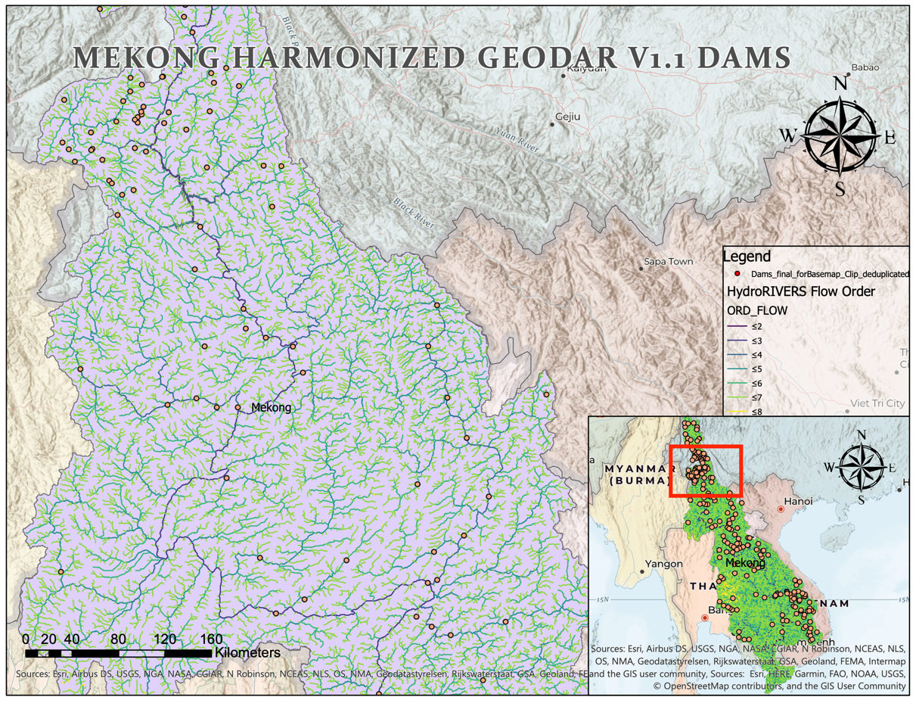
Figure 7

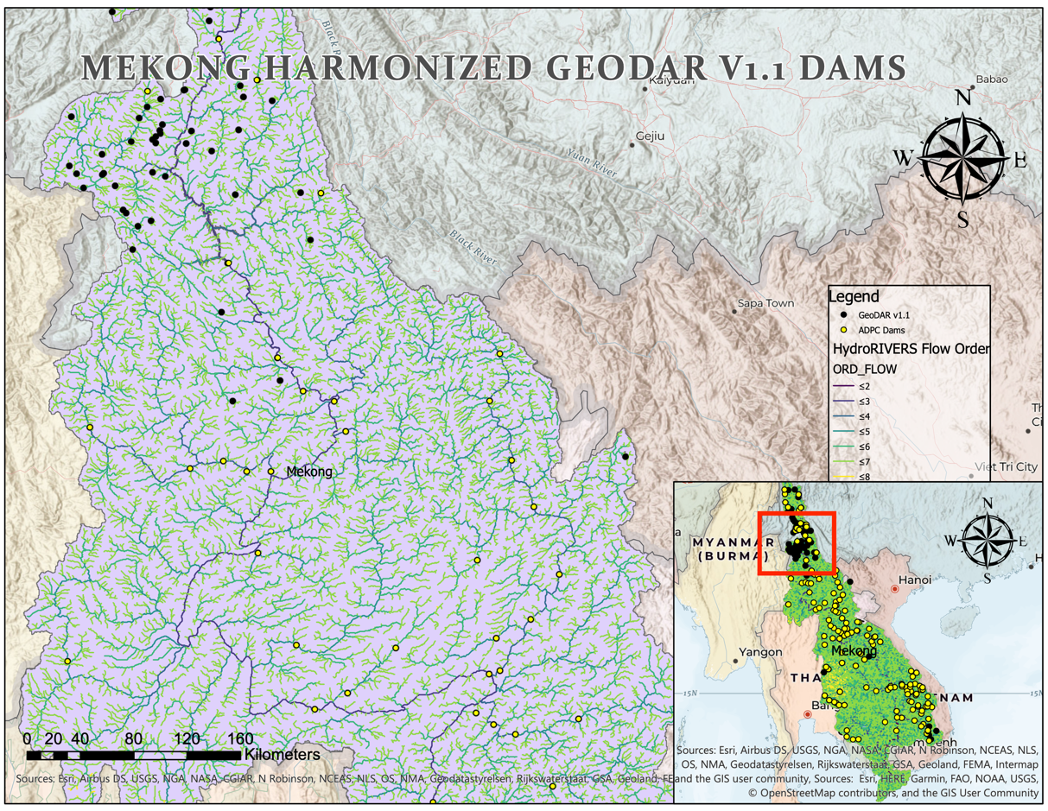
Figure 8

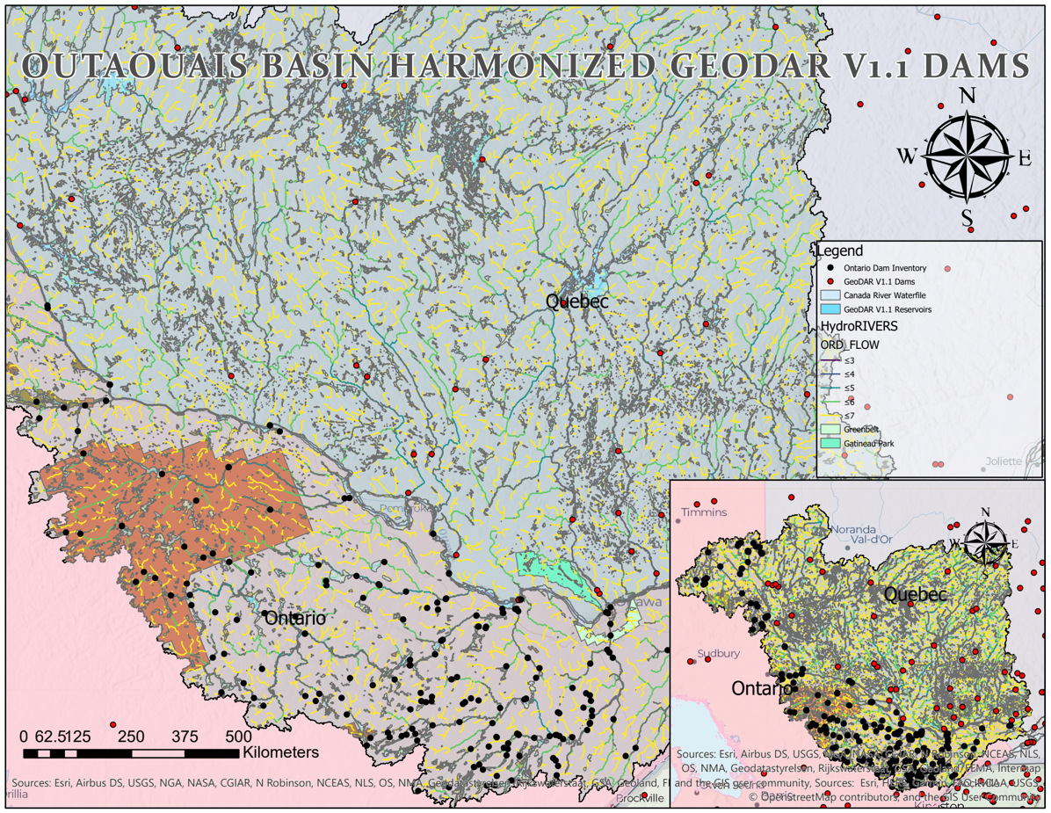
Figure 9

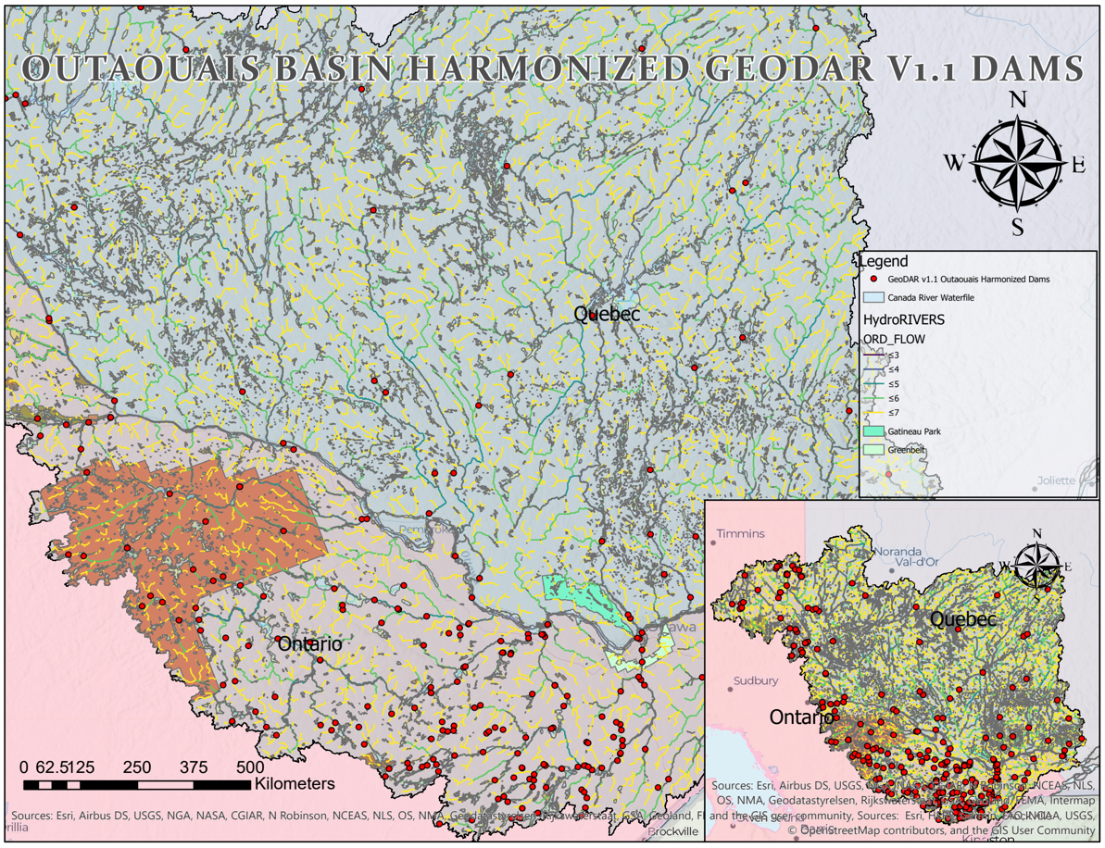
Figure 10

Figure 12

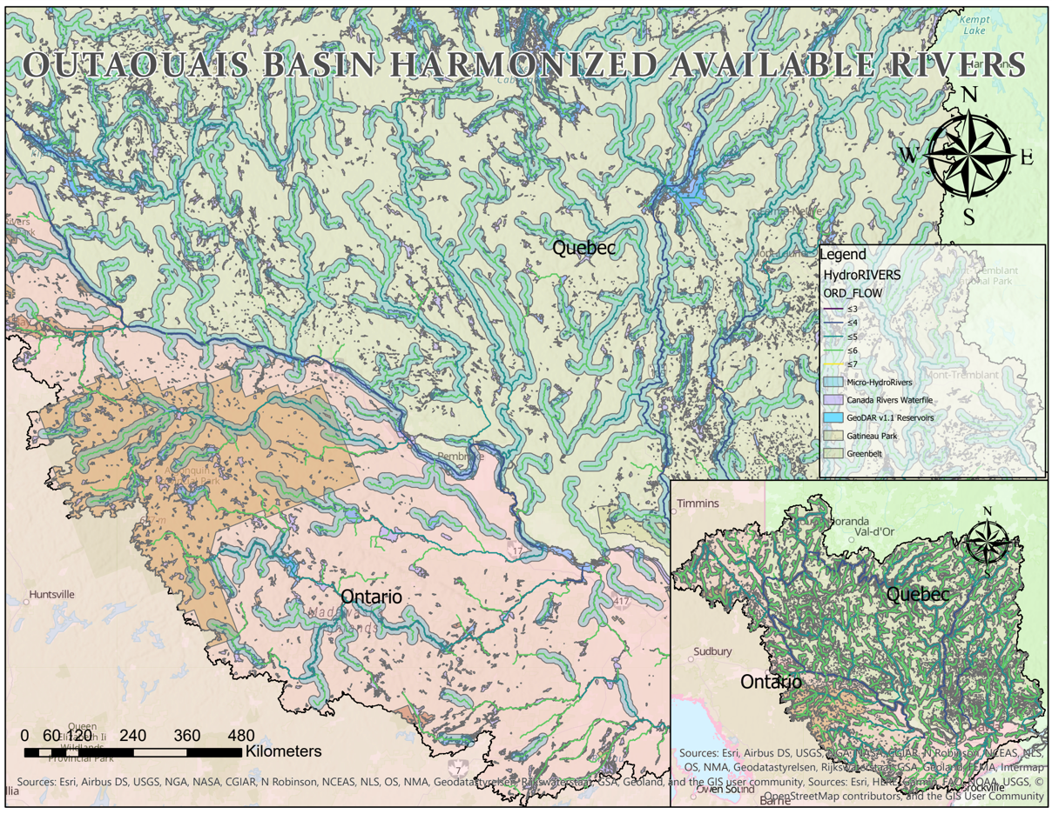
Figure 13

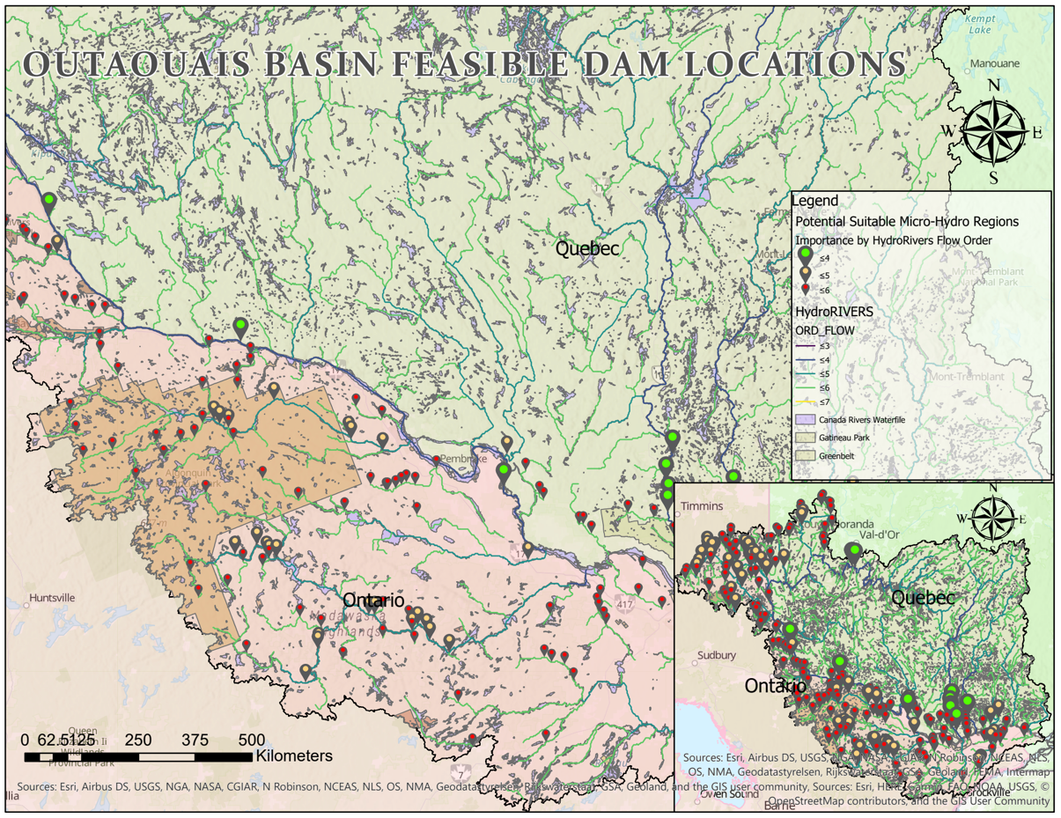
Figure 14

Appendix B: DATABASE DIAGRAMS AND CHARTS

Figure 1
Figure 2
Figure 3

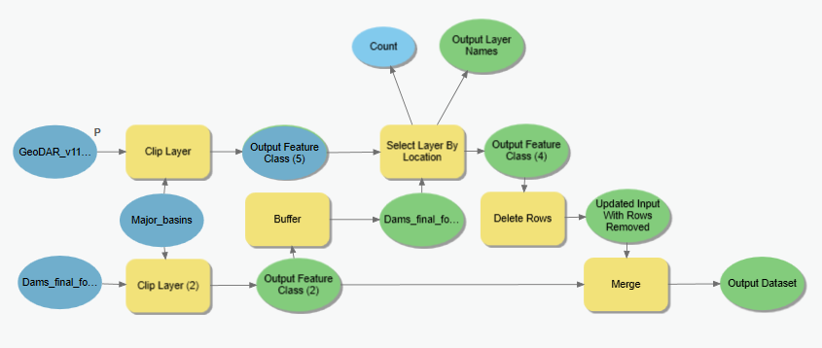
Figure 4

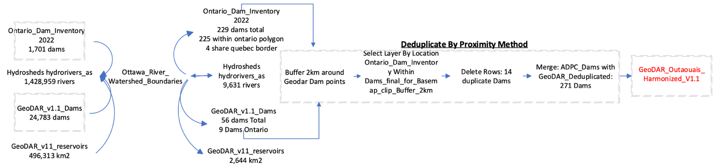
Figure 5

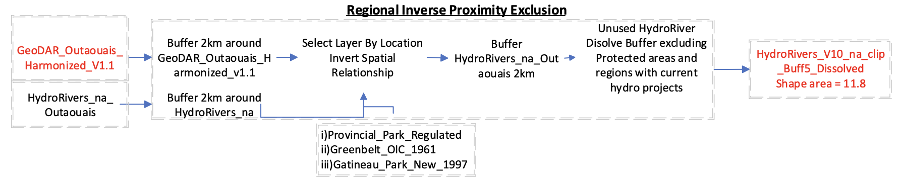
Figure 6

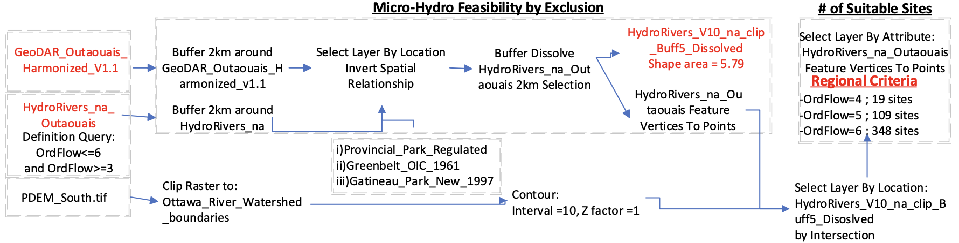
Figure 7
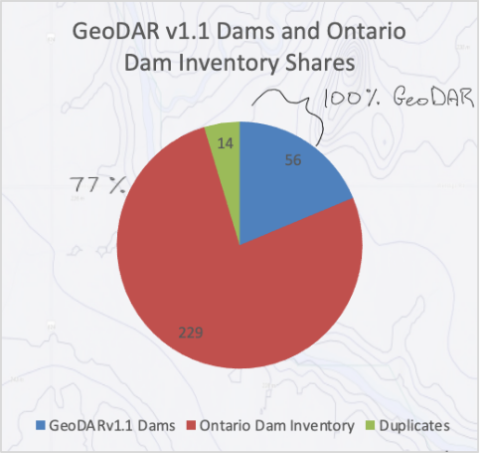

Figure 11

Appendix C: DATA SOURCES AND DOCUMENTATION

“Protected Areas - Canada,” Open Government Portal. [Online]. Available: https://open.canada.ca/data/en/dataset/6c343726-1e92-451a-876a-76e17d398a1c. [Accessed: 29-Jul-2022].
“Water file - lakes and rivers (polygons) - 2011 census,” Open Government Portal. [Online]. Available: https://open.canada.ca/data/en/dataset/448ec403-6635-456b-8ced-d3ac24143add. [Accessed: 29-Jul-2022].
“Provincial Park regulated,” Ontario GeoHub. [Online]. Available: https://geohub.lio.gov.on.ca/datasets/provincial-park-regulated/explore?location=45.394826%2C-76.937830%2C5.82. [Accessed: 29-Jul-2022].
Yronald, “GMS major river basins,” Greater Mekong Subregion (GMS), 10-Feb-2021. [Online]. Available: https://greatermekong.org/gms-major-river-basins. [Accessed: 29-Jul-2022].
“Ontario Dam Inventory,” Ontario GeoHub. [Online]. Available: https://geohub.lio.gov.on.ca/datasets/mnrf::ontario-dam-inventory/explore?location=44.790961%2C-78.069133%2C3.74. [Accessed: 29-Jul-2022].
Lehner, B., Verdin, K., Jarvis, A. (2008): New global hydrography derived from spaceborne elevation data. Eos, Transactions, 89(10): 93-94. Data available at https://www.hydrosheds.org
“Provincial Digital Elevation Model (PDEM),” Ontario GeoHub. [Online]. Available: https://geohub.lio.gov.on.ca/maps/mnrf::provincial-digital-elevation-model-pdem/explore?location=32.390239%2C-85.372324%2C1.90. [Accessed: 29-Jul-2022].
“Government of Canada,” Open Government, 01-Mar-2019. [Online]. Available: https://search.open.canada.ca/en/od/?organization=nrcan-rncan. [Accessed: 29-Jul-2022].
“Map,” Global Dam Watch, 04-Nov-2021. [Online]. Available: https://globaldamwatch.org/map/. [Accessed: 29-Jul-2022].

